**SUMMER** 

**2016**

**TOP 100 BAR**

***Salty’s Bar Philosophy***

*At Salty’s we strive to create trend setting and world class drinks. We are a constantly evolving bar concept using the finest ingredients with attention to every detail. From house made syrups to hand crafted cocktails from around the world you will not find a more inspired and specialized bar program within our market. We take pride in the art of pouring the perfect drink; it is held in high esteem to be considered a bartender as a profession at Salty’s. Each year Salty’s will introduce new cocktails, martinis and shooters to our seasonal menus that celebrate what is new and hot in the world of mixology. A great bar is not only about great cocktails but great experiences. Through talented, knowledgeable and entertaining bar partners we create an atmosphere that guests know will provide them an exceptional experience where we take the craft of cocktail making seriously.*

**TABLE OF CONTENTS**

**SALTYS COCKTAILS**

**SALTYS COCKTAIL BANANA BAILEYS 13**

**SALTYS COCKTAIL BANGKOK CAESAR 14**

**SALTYS COCKTAIL BASIL GIN FIZZ 15**

**SALTYS COCKTAIL BIG DOG 16**

**SALTYS COCKTAIL BLUE HAWAII 17**

**SALTYS COCKTAIL BOAT DRINK 18**

**SALTYS COCKTAIL CUBA LIBRE 19**

**SALTYS COCKTAIL CUCUMBER GIN MOJITO 20**

**SALTYS COCKTAIL THE DARK N STORMY 21**

**SALTYS COCKTAIL THE HURRICANE 22**

**SALTYS COCKTAIL JALEPENO MARGARITA 23**

**SALTYS COCKTAIL KEY LIME PIE MARTINI 24**

**SALTYS COCKTAIL KINKY REGGAE PARTY 25**

**SALTYS COCKTAIL OLD FASHIONED CAESAR 26**

**SALTYS COCKTAIL PLANTERS PUNCH 27**

**SALTYS COCKTAIL RASPBERRY BASIL COLLINS 28**

**SALTYS COCKTAIL THE SHARK ATTACK 29**

**SALTYS COCKTAIL CHI CHI 30**

**SALTYS COCKTAIL CLASSIC CAESAR 31**

**SALTYS COCKTAIL CLASSIC MOJITO 32**

**SALTYS COCKTAIL FRENCH MARTINI 33**

**SALTYS COCKTAIL FROZEN MARGARITA 34**

**SALTYS COCKTAIL ROCKS MARGARITA 35**

**SALTYS COCKTAIL PINA COLADA 36**

**SALTYS SHOOTER THE CORAL REEF (ROUND OF 4) 37**

**SALTYS SHOOTER THE SHIPWRECK SHOOTERS (ROUND OF 4) 38**

**SEASONAL COCKTAILS**

**SEASONAL COCKTAIL RED BERRY SANGRIA (w/ALC) 39**

**SEASONAL COCKTAIL WHITE PEACH SANGRIA (w/ALC) 40**

**SEASONAL COCKTAIL RED BERRY SANGRIA GLASS (w/ALC) 41**

**SEASONAL COCKTAIL WHITE PEACH SANGRIA GLASS (w/ALC) 42**

**STANDARD COCKTAILS A-Z**

**STANDARD COCKTAIL AMERICANO 43**

**STANDARD COCKTAIL APPLETINI 44**

**STANDARD COCKTAIL BLACK RUSSIAN 45**

**STANDARD COCKTAIL BLOODY MARY 46**

**STANDARD COCKTAIL CAESAR 47**

**STANDARD COCKTAIL CAIPIRINHA 48**

**STANDARD COCKTAIL COLLINS 49**

**STANDARD COCKTAIL COSMOPOLITAN 50**

**STANDARD COCKTAIL CRANTINI 51**

**STANDARD COCKTAIL DAIQUIRI TRADITIONAL 52**

**STANDARD COCKTAIL GIMLET 53**

**STANDARD COCKTAIL GREYHOUND 54**

**STANDARD COCKTAIL LEMON DROP 55**

**STANDARD COCKTAIL LONG ISLAND ICED TEA 56**

**STANDARD COCKTAIL MANHATTAN 57**

**STANDARD COCKTAIL MARTINI GIN 58**

**STANDARD COCKTAIL MARTINI VODKA 59**

**STANDARD COCKTAIL MIMOSA 60**

**STANDARD COCKTAIL MINT JULEP 61**

**STANDARD COCKTAIL NEGRONI 62**

**STANDARD COCKTAIL PARALYZER (TRADITIONAL) 63**

**SEASONAL COCKTAIL PIMMS CUP 64**

**STANDARD COCKTAIL ROB ROY 65**

**STANDARD COCKTAIL RUSTY NAIL 66**

**STANDARD COCKTAIL SIDECAR 67**

**STANDARD COCKTAIL SINGAPORE SLING 68**

**STANDARD COCKTAIL SOUR 69**

**STANDARD COCKTAIL TOMMY’S MARGARITA 70**

**STANDARD COCKTAIL WHITE RUSSIAN 71**

**STANDARD SHOOTERS**

**SHOOTER AFTER EIGHT 72**

**SHOOTER APPLE PIE 73**

**SHOOTER BABY GUINNESS 74**

**SHOOTER BANANA JACK 75**

**SHOOTER BANZAI BERRY 76**

**SHOOTER BLONDIE 77**

**SHOOTER BAZOOKA JOE 78**

**SHOOTER BJ SHOOTER 79**

**SHOOTER BROKEN DOWN GOLF CART 80**

**SHOOTER BURT REYNOLDS 81**

**SHOOTER B 52 82**

**SHOOTER CHEAP DATE 83**

**SHOOTER CHINA WHITE 84**

**SHOOTER C- SHOT 85**

**SHOOTER CRISPY CRUNCH 86**

**SHOOTER DR. PEPPER 87**

**SHOOTER GOD FATHER 89**

**SHOOTER IRISH CAR BOMB 90**

**SHOOTER KING KONG (ROCK STAR) 91**

**SHOOTER KAMIKAZE 92**

**SHOOTER LEMON DROP 93**

**SHOOTER LIQUID COCAINE 94**

**SHOOTER MAGNUM PI 95**

**SHOOTER MONKEY’S LUNCH 96**

**SHOOTER MUFF DIVER 97**

**SHOOTER OBAMA 98**

**SHOOTER PORN STAR 99**

**SHOOTER POLAR BEAR 100**

**SHOOTER PRAIRIE FIRE 101**

**SHOOTER RED HEADED SLUT 102**

**SHOOTER RED DRAGON 103**

**SHOOTER SEX ON THE BEACH 104**

**SHOOTER SICILIAN KISS 106**

**SHOOTER SOUR JACK 107**

**SHOOTER SURFER ON ACID 108**

**SHOOTER ROCKY MOUNTAIN BEAR F***** 109**

**SHOOTER WASHINGTON APPLE 110**

**SHOOTER WOO WOO 111**

**SHOOTER 4 HORSEMEN 112**

**SERVING STANDARDS**

**STANDARD BEER BOTTLE 113**

**STANDARD BEER DRAUGHT 114**

**STANDARD HIGH BALL 115**

**STANDARD NEAT 116**

**STANDARD ON THE ROCKS 117**

**STANDARD SIDECAR (ON THE SIDE) 118**

**STANDARD WINE 119**

**SPECIALTY COFFEES**

**SPECIALTY COFFEE B52 120**

**SPECIALTY COFFEE BAILEYS 121**

**SPECIALTY COFFEE BLUEBERRY TEA 122**

**SPECIALTY COFFEE HOT TODDY 123**

**SPECIALTY COFFEE IRISH COFFEE 124**

**SPECIALTY COFFEE MEXICAN COFFEE 125**

**SPECIALTY COFFEE MONTE CRISTO 126**

**SPECIALTY COFFEE SPANISH COFFEE/MADRID 127**

**COFFEE & TEA**

**COFFEE & TEA COFFEE 128**

**COFFEE & TEA HOT CHOCOLATE 129**

**COFFEE & TEA TEA 130**

**ALCOHOL FREE**

**ALCOHOL FREE ARNOLD PALMER 131**

**ALCOHOL FREE BOTTLED WATER 132**

**ALCOHOL FREE FENTIMANS TONIC WATER 133**

**ALCOHOL FREE ICED LATTE 134**

**ALCOHOL FREE JUICE WITH ICE 135**

**ALCOHOL FREE JUICE WITHOUT ICE OR MILK 136**

**ALCOHOL FREE JUICE WITH SODA 137**

**ALCOHOL FREE LEMONADE 138**

**ALCOHOL FREE ROY ROGERS 139**

**ALCOHOL FREE RED BULL 140**

**ALCOHOL FREE SHIRLEY TEMPLE 141**

**ALCOHOL FREE SOFT DRINKS 142**

**ALCOHOL FREE VIRGIN MARGARITA FLAVORED 143**

THE BANANA BAILEYS COLADA 

___________________________________________________________________________________________



**Presentation:**

**The Guest Expectation:**

A Classic Pina Colada, with a Salty’s twist

**Technique:** Blend

**Glassware:** Hurricane

**Garnish:** Pineapple Wedge

**Bill Time:** 1 Min

**Ingredients:**

|  |  |
| --- | --- |
| INGREDIENTS | QUANTITY |
| BAILEY’S | **SG:** 1oz  **SS:** 1.5oz |
| BOLS BANANA | **SG:** .5oz  **SS:** 1oz |
| COCONUT SYRUP | .5oz |
| MILK | 1.5oz |
| PINEAPPLE JUICE | 1.5oz |



THE BANGKOK CAESAR (SPICY!)

___________________________________________________________________________________________

**Presentation:**

**The Guest Expectation:**

Perfectly spiced and (fresh fruit/veg) garnished cocktail

**Technique:** Build

**Glassware:** Shaker Glass

**Garnish:** 1 Olive, 1 Celery, 1 Lime, Celery Salt Rim

**Bill Time:** 1 Min

**Ingredients:**

|  |  |
| --- | --- |
| INGREDIENTS | QUANTITY |
| POLAR ICE VODKA | 1oz.  SS 2oz. |
| CLAMATO | FILL |
| WORCHESIRE SAUCE | TO TASTE- AVG 1.5 TO 2OZ |
| SAMBAL | TO TASTE- AVG 1-2 BARSPOONS |
| CELERY SALT | RIM |



THE BASIL GIN FIZZ

___________________________________________________________________________________________

**Presentation:**

**The Guest Expectation:**

Refreshing look, fresh basil.

**Technique:** Muddle &Build

**Glassware:** Mojito Glass

**Garnish:** Lemon wedge

**Bill Time:** 1 Min

**Ingredients:**

|  |  |
| --- | --- |
| INGREDIENTS | QUANTITY |
| BEEFEATER GIN | 1oz.  SS 2oz. |
| FRESH BASIL | 4-6 LEAVES |
| LEMON WEDGE | 1 |
| LEMONADE | 3oz. |
| SODA | 2oz. |



THE BIG DOG

___________________________________________________________________________________________

**Presentation:**

**The Guest Expectation:**

Authentic presentation, clip on the rim

**Technique:** Build

**Glassware:** Big Dog Glass, Coronita clip

**Garnish:** Lime

**Bill Time:** 1 Min

**Ingredients:**

|  |  |
| --- | --- |
| INGREDIENTS | QUANTITY |
| OLMECA TEQUILA | 1oz.  SS 2oz. |
| BAR LIME | FILL TO ¾ FULL |
| CORONITA | 1 |



THE BLUE HAWAII

___________________________________________________________________________________________

**Presentation:**

**The Guest Expectation:**

A fun, tropical, blue cocktail.

**Technique:** Build

**Glassware:** Hurricane Glass

**Garnish:** Pineapple Wedge



**Bill Time:** 1 Min

**Ingredients:**

|  |  |
| --- | --- |
| INGREDIENTS | QUANTITY |
| LAMB’S WHITE RUM | 1oz. |
| MALIBU | .5oz. |
| BOLS BLUE | .5oz. |
| PINEAPPLE JUICE | TOP |



THE BOAT DRINK

___________________________________________________________________________________________

**Presentation:**

**The Guest Expectation:**

Vibrant colour, tropical flavour, fresh orange garnish.

**Technique:** Build

**Glassware:** Mini Pitcher

**Garnish:** Orange, Umbrella



**Bill Time:** 1 Min

**Ingredients:**

|  |  |
| --- | --- |
| INGREDIENTS | QUANTITY |
| MALIBU RUM | 1oz.  SS 1.5oz. |
| LAMB’S WHITE RUM | 1oz.  SS 1.5oz. |
| ORANGE JUICE | 3oz. |
| PINEAPPLE JUICE | 3oz. |



THE CUBA LIBRE

___________________________________________________________________________________________

**Presentation:**

**The Guest Expectation:**

A highball with a splash of lime juice

**Technique:** Build

**Glassware:** Rocks

**Garnish:** Lime Wedge



**Bill Time:** 1 Min

**Ingredients:**

|  |  |
| --- | --- |
| INGREDIENTS | QUANTITY |
| LAMB’S | 1oz  SS: 2oz |
| LIME JUICE | Splash |
| COKE | TOP |



THE CUCUMBER-GIN MOJITO

___________________________________________________________________________________________

**Presentation:**

**The Guest Expectation:**

Refreshing look, fresh mint & cucumber

**Technique:** Muddle &Build

**Glassware:** Collins Glass

**Garnish:** Cucumber



**Bill Time:** 1 Min

**Ingredients:**

|  |  |
| --- | --- |
| INGREDIENTS | QUANTITY |
| LAMB’S WHITE RUM | 1oz.  SS 2oz. |
| FRESH MINT | 4 Leaves |
| FRESH CUCUMBER | 4 Slices |
| LIME WEDGE | 1 (Muddle) |
| LIME JUICE | Splash |
| SIMPLE SYRUP | .5oz. |
| SODA | Top |



THE DARK & STORMY

___________________________________________________________________________________________

**Presentation:**

**The Guest Expectation:**

A refreshing tall drink, with a kick

**Technique:** Build

**Glassware:** Collins Glass

**Garnish:** Lime Wedge



**Bill Time:** 1 Min

**Ingredients:**

|  |  |
| --- | --- |
| INGREDIENTS | QUANTITY |
| KRAKEN RUM | .5oz. |
| GINGER SYRUP | 1.5oz. |
| SODA WATER | Top |



THE HURRICANE

___________________________________________________________________________________________

**Presentation:**

**The Guest Expectation:**

A classic and tropical rum drink.

**Technique:** Shake and Strain

**Glassware:** Hurricane Glass

**Garnish:** Pineapple Wedge



**Bill Time:** 1 Min

**Ingredients:**

|  |  |
| --- | --- |
| INGREDIENTS | QUANTITY |
| KRAKEN RUM  SAILOR JERRY’S RUM  HAVANA CLUB RUM  LAMB’S WHITE RUM | .5oz  .5oz  .5oz  .5oz |
| PASSIONFRUIT CORDIAL | .5oz. |
| LEMONADE | 1oz. |
| SODA WATER | Top |



THE JALAPENO MARGARITA

___________________________________________________________________________________________

**Presentation:**

**The Guest Expectation:**

A fresh take on the classic Margarita with an added kick

**Technique:** Muddle, Shake & Strain

**Glassware:** Margarita Glass

**Garnish:** Lime Wedge



**Bill Time:** 1 Min

**Ingredients:**

|  |  |
| --- | --- |
| INGREDIENTS | QUANTITY |
| TEQUILA | 1oz.  SS: 2oz. |
| SIMPLE SYRUP | 75oz. |
| TRIPLE SEC | .25oz |
| LIME JUICE | 1oz. |
| WATER | 1oz.  **\*for a salty’s size, omit water and replace with 1oz. tequila** |
| GREEN JALAPENO | 2 slices |



THE KEY LIME PIE MARTINI

___________________________________________________________________________________________

**Presentation:**

**The Guest Expectation:** 

A sweet dessert martini

**Technique:** Shake and Strain

**Glassware:** Chilled martini

**Garnish:** Lime wedge, graham cracker rim



**Bill Time:** 1 Min

**Ingredients:**

|  |  |
| --- | --- |
| INGREDIENTS | QUANTITY |
| VANILLA VODKA | 2oz |
| COCONUT SYRUP | .5oz |
| PINEAPPLE JUICE | 2oz |
| LIME JUICE | 1oz |



THE KINKY REGGAE PARTY

___________________________________________________________________________________________

**Presentation:**

**The Guest Expectation:**

Raspberry, fruity, an old Salty’s classic.

**Technique:** Build

**Glassware:** Hurricane Glass

**Garnish:** Lemon, Umbrella



**Bill Time:** 2 Min

**Ingredients:**

|  |  |
| --- | --- |
| INGREDIENTS | QUANTITY |
| SOUTHERN COMFORT | .5oz  SS: 1oz |
| ABSOLUT RASPBERI | .5oz.  SS 1oz. |
| RASPBERRY PUREE | 1oz |
| CRANBERRY JUICE | 2oz |
| ORANGE POP | Top |



THE OLD FASHIONED CAESAR

___________________________________________________________________________________________

**Presentation:**

**The Guest Expectation:**

Perfectly spiced and (fresh fruit/veg) garnished cocktail

**Technique:** Build

**Glassware:** Shaker Glass

**Garnish:** 1 Olive, 1 Celery, 1 Lime, Sea Salt Rim



**Bill Time:** 1 Min

**Ingredients:**

|  |  |
| --- | --- |
| INGREDIENTS | QUANTITY |
| BEEFEATER GIN | 1oz.  SS 2oz. |
| CLAMATO | FILL |
| WORCHESIRE SAUCE | TO TASTE- AVG 1.5 TO 2OZ |
| TOBASCO | TO TASTE- AVG 2 DASHES |
| HORSERADISH | BARSPOON |
| HIMILAYAN SEA SALT | RIM |



THE PLANTER’S PUNCH

___________________________________________________________________________________________

**Presentation:**

**The Guest Expectation:**

A strong, fruity rum drink

**Technique:** Shake & pour

**Glassware:** Hurricane

**Garnish:** Pineapple Wedge



**Bill Time:** 1 Min

**Ingredients:**

|  |  |
| --- | --- |
| INGREDIENTS | QUANTITY |
| LAMB’S DARK RUM | 1oz |
| LAMB’S WHITE RUM | 1oz |
| GRENADINE | .5oz |
| LEMON JUICE | .5oz |
| ORANGE JUICE | 1oz |
| PINEAPPLE JUICE | 2oz |
| ANGOSTURA BITTERS | 2 dashes |



THE RASPBERRY BASIL COLLINS

___________________________________________________________________________________________

**Presentation:**

**The Guest Expectation:**

A fruity, herbaceous twist on the classic cocktail.

**Technique:** Muddle, Build

**Glassware:** Collins Glass

**Garnish:** Lemon Peel



**Bill Time:** 1 Min

**Ingredients:**

|  |  |
| --- | --- |
| INGREDIENTS | QUANTITY |
| GIN | 1oz.  SS: 2oz. |
| SIMPLE SYRUP | 1oz. |
| LEMON JUICE | 1oz. |
| BASIL | 4-6 Leaves |
| FROZEN RASPBERRIES | 1 Portion |
| SODA | Top |



THE SHARK ATTACK (2 PERSON MIN)

___________________________________________________________________________________________

**Presentation:**

**The Guest Expectation:**

Bowl should resemble ‘bloody water’

**Technique:** Build

**Glassware:** Fish Bowl

**Garnish:**



**Bill Time:** 1 Min

**Ingredients:**

|  |  |
| --- | --- |
| INGREDIENTS | QUANTITY |
| POLAR ICE VODKA | 4oz. |
| BLUE CURACAO | 2oz. |
| SPRITE | EQUAL FILL |
| SODA | EQUAL FILL |
| BAR LIME | EQUAL FILL |
| GRENEDINE | RIM INSIDE OF BOWL |



THE CHI CHI

___________________________________________________________________________________________

**Presentation:**

**The Guest Expectation:**

Summery tropical drink

**Technique:** Blend

**Glassware:** Hurricane

**Garnish:** Orange Wedge



**Bill Time:** 1 Min

**Ingredients:**

|  |  |
| --- | --- |
| INGREDIENTS | QUANTITY |
| VODKA | **SG:** 1oz  **SS:** 2oz |
| MILK | 1.5oz |
| PINEAPPLE JUICE | 2oz |
| COCONUT SYRUP | .5oz |



THE CLASSIC CAESAR

___________________________________________________________________________________________

**Presentation:**

**The Guest Expectation:**

Perfectly spiced and (fresh fruit/veg) garnished cocktail

**Technique:** Build

**Glassware:** Shaker Glass

**Garnish:** 1 Olive, 1 Celery, 1 Lime, Celery Salt Rim



**Bill Time:** 1 Min

**Ingredients:**

|  |  |
| --- | --- |
| INGREDIENTS | QUANTITY |
| POLAR ICE VODKA | 1oz.  SS 2oz. |
| CLAMATO | FILL |
| WORCHESIRE SAUCE | TO TASTE- AVG 1.5 TO 2OZ |
| TOBASCO | TO TASTE- AVG 2 DASHES |
| CELERY SALT | RIM |



THE CLASSIC MOJITO

___________________________________________________________________________________________

**Presentation:**

**The Guest Expectation:**

Refreshing look, fresh mint

**Technique:** Muddle &Build

**Glassware:** Collins Glass

**Garnish:** Mint Sprig



**Bill Time:** 1 Min

**Ingredients:**

|  |  |
| --- | --- |
| INGREDIENTS | QUANTITY |
| HAVANA CLUB | 1oz.  SS 2oz. |
| FRESH MINT | 6-10 Leaves |
| LIME WEDGE | 1 (Muddle) |
| LIME JUICE | DASH |
| SIMPLE SYRUP | .5oz |
| SODA | TOP |

**For Berry Mojito just add mixed berry portion**



THE FRENCH MARTINI

___________________________________________________________________________________________

**Presentation:**

**The Guest Expectation:** 

An exotic, fruity gin cocktail

**Technique:** Shake and Strain

**Glassware:** Chilled martini

**Garnish:** None



**Bill Time:** 1 Min

**Ingredients:**

|  |  |
| --- | --- |
| INGREDIENTS | QUANTITY |
| GIN | 1.5oz |
| CHAMBORD | .5oz |
| PINEAPPLE JUICE | 2oz |



THE FROZEN MARGARITA

___________________________________________________________________________________________

**Presentation:**

**The Guest Expectation:**

A cold, slushy margarita.

**Technique:** Blend

**Glassware:** Margarita glass

**Garnish:** ½ Salted rim &Lime Wedge



**Bill Time:** 1 Min

**Ingredients:**

|  |  |
| --- | --- |
| INGREDIENTS | QUANTITY |
| ICE | Full marg glass |
| OLMECA BLANCO TEQUILA | SG: 1oz.  SS: 2oz. |
| TRIPLE SEC | .25oz |
| BAR LIME | 2oz |



THE ROCKS MARGARITA

___________________________________________________________________________________________

**Presentation:**

**The Guest Expectation:**

A traditional margarita, served on the rocks.

**Technique:** Shake and Strain

**Glassware:** Margarita glass

**Garnish:** ½ Salted rim &Lime Wedge



**Bill Time:** 1 Min

**Ingredients:**

|  |  |
| --- | --- |
| INGREDIENTS | QUANTITY |
| OLMECA BLANCO TEQUILA | SG: 1oz.  SS: 2oz. |
| LIME JUICE | 1oz |
| TRIPLE SEC | .25oz |
| SIMPLE SYRUP | .75oz |
| WATER | 1oz  **\*note: for a double, replace water w/ 1oz tequila** |



THE PIÑA COLADA

___________________________________________________________________________________________

**Presentation:**

**The Guest Expectation:**

Summery tropical drink

**Technique:** Blend

**Glassware:** Hurricane

**Garnish:** Orange Wedge



**Bill Time:** 1 Min

**Ingredients:**

|  |  |
| --- | --- |
| INGREDIENTS | QUANTITY |
| LAMB’S WHITE RUM | **SG:** 1oz  **SS:** 2oz |
| MILK | 1.5oz |
| PINEAPPLE JUICE | 2oz |
| COCONUT SYRUP | .5oz |



THE CORAL REEF (ROUND OF 4)

___________________________________________________________________________________________

**Presentation:**

**The Guest Expectation:**

Chilled, well-mixed shooter

**Technique:** Shake and Strain

**Glassware:** 4Shot Glasses

**Garnish:** None

**Bill Time:** 1 Min

**Ingredients:**

|  |  |
| --- | --- |
| INGREDIENTS | QUANTITY |
| ALIZE LIQUEUR | 2oz. |
| MALIBU RUM | 2oz. |



THE SHIPWRECK SHOOTER (ROUND OF 4)

___________________________________________________________________________________________

**Presentation:**

**The Guest Expectation:**

Chilled, well-mixed shooter

**Technique:** Shake and Strain

**Glassware:** 4 Shot Glasses

**Garnish:** None

**Bill Time:** 1 Min

**Ingredients:**

|  |  |
| --- | --- |
| INGREDIENTS | QUANTITY |
| CAPTAIN MORGAN’S SPICED RUM | 2OZ |
| BUTTER RIPPLE SCHNAPPS | 2OZ. |

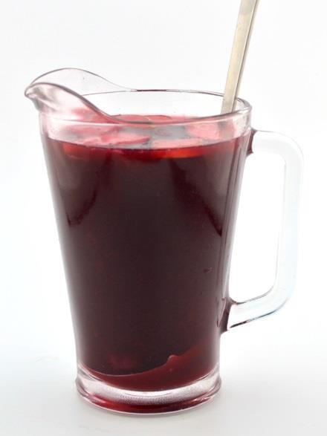

|  |  |
| --- | --- |
| **QUANTITY** | **INGREDIENTS:** |
| 1 L | Pre Portioned Red Sangria |

**RECIPE:**

1. Pour entire contents of Pre Portioned Sangria directly into Sangria

Pitcher **without** ice.

2. Add the approved Ladle

3. Serve with proper number of Riedel Wine glasses (**PACKED FULL)**

with ice

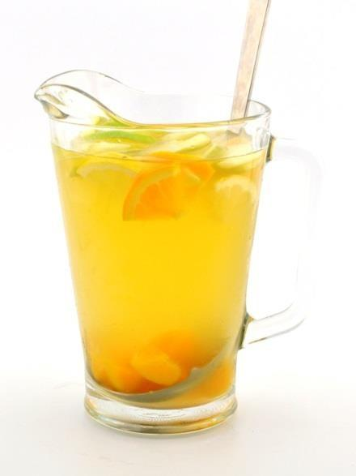

|  |  |
| --- | --- |
| **QUANTITY** | **INGREDIENTS:** |
| 1 L | Pre Portioned White Sangria |

**RECIPE:**

1. Pour entire contents of Pre Portioned Sangria directly into Sangria

Pitcher **without** ice.

2. Add the approved Ladle

3. Serve with proper number of Riedel Wine glasses (**PACKED FULL)**

with ice and 6” Straw.

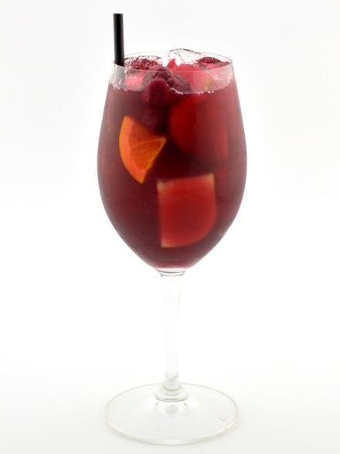

|  |  |
| --- | --- |
| **QUANTITY** | **INGREDIENTS:** |
| 6 fl oz | Pre Mixed Sangria With Alcohol |

**RECIPE:**

1. Pack a Riedel Wine glass **Full of Ice**

2. Fill glass with 6 fl oz of Sangria.

3. Garnish with 5 pre-portioned pieces of Sangria Fruit

4. Add a 6” Straw

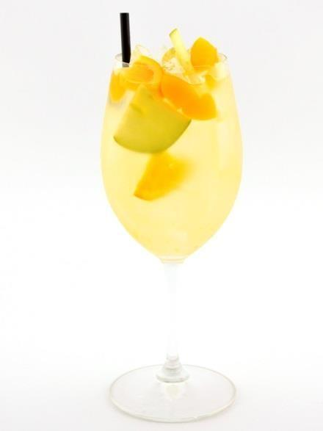

|  |  |
| --- | --- |
| **QUANTITY** | **INGREDIENTS:** |
| 6 fl oz | Pre Mixed Sangria With Alcohol |

**RECIPE:**

1. Pack a Riedel Wine glass **Full of Ice**

2. Fill glass with 6 fl oz of Sangria.

3. Garnish with 5 pre-portioned pieces of Sangria Fruit

4. Add a 6” Straw

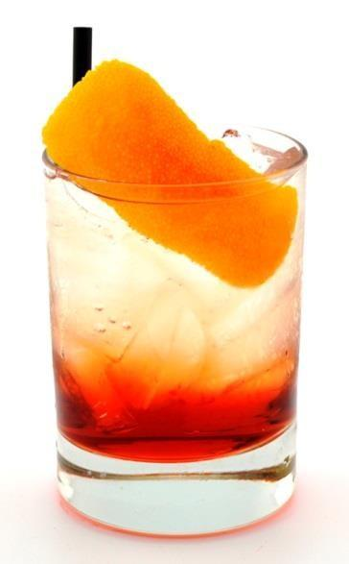

|  |  |
| --- | --- |
| **QUANTITY** | **INGREDIENTS:** |
| 0.5 fl oz | Campari |
| 0.5 fl oz | Sweet Vermouth |
| 3 fl oz * | Soda Water *(fill with soda approximate volume) |

**RECIPE:**

1. Pack a Double Rocks glass full of ice.

2. Measure 0.5 fl oz Campari, 0.5 fl oz Sweet Vermouth and pour over ice.

3. Top with 3 fl oz of Soda Water

4. Top with ice level with the rim of the glass.

5. Garnish with an Orange Zest

6. Add a 6” Straw.

**DOUBLE:** Add 0.5 fl oz Campari & 0.5 fl oz Sweet Vermouth

**FUN FACT:** The Americano was created in the 1860’s by Gaspare Campari who as well invented Campari. It was originally named the Milano-Torino paying homage to the origins of the two ingredients Campari and Cinzano. The name was changed during prohibition when American tourists began to drink them in excess.

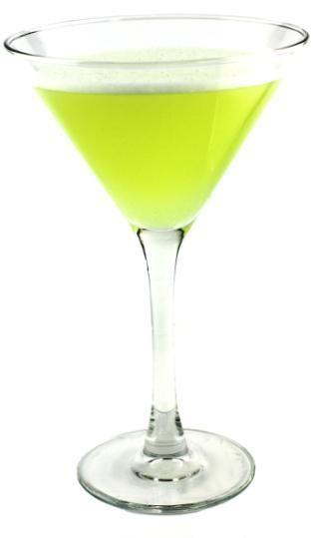

|  |  |
| --- | --- |
| **QUANTITY** | **INGREDIENTS:** |
| 1 fl oz | Simple Syrup |
| 1 fl oz | Fresh Lime Juice |
| 1 fl oz | Sour Puss Apple |
| 1 fl oz | Green Apple Vodka |

**RECIPE:**

1. In a Mixing glass, measure 1 fl oz Simple Syrup, 1 fl oz Fresh Lime Juice, 1 fl oz Sour Puss Apple, and 1 fl oz Green Apple Vodka.

2. Pack Mixing glass full with ice. Top with a stainless steel Shaking tin.

3. Pack Martini Glass full with ice and top with soda water to chill glass.

4. Shake vigorously 12 times to mix ingredients.

5. Empty chilling ice and soda from Martini Glass into dump sink.

6. Strain into a chilled Martini glass.

**DOUBLE:** Add 0.5 fl oz Sour Puss Apple and 0.5 fl oz Green Apple

Vodka

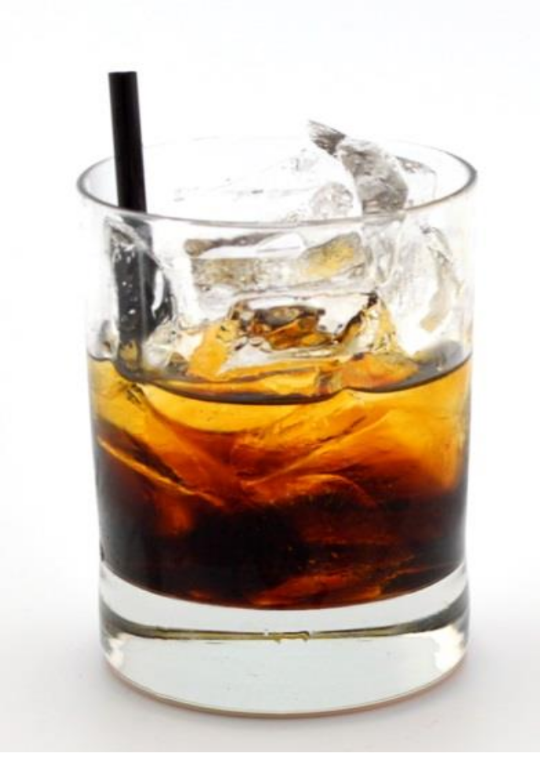

|  |  |
| --- | --- |
| **QUANTITY** | **INGREDIENTS:** |
| 0.5 fl oz | Well Vodka |
| 0.5 fl oz | Kahlua |

**RECIPE:**

1. Pack a Small Rocks glass full of ice.

2. Measure 0.5 fl oz Well Vodka and 0.5 fl oz Kahlua and pour over ice.

3. Add a 6” Straw.

**DOUBLE:** Add 0.5 fl oz Well Vodka & 0.5 fl oz Kahlua

**FUN FACT**: Created in 1949 in Belgium by a bartender at the Hotel Metropole, the Black Russian is not a traditional Russian drink, but rather a pun on the name of the anti-Bolshevic “White Russians” from the Russian Civil War.

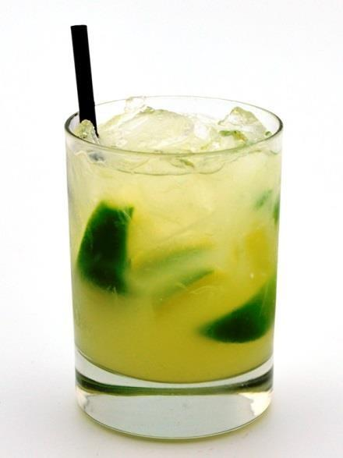

|  |  |
| --- | --- |
| **QUANTITY** | **INGREDIENTS:** |
| 4 wedges | Lime (1/8th wedge) |
| 1 fl oz | Simple Syrup |
| 0.5 fl oz | Fresh Lime Juice |
| 0.5 fl oz | Water |
| 1 fl oz | Cachaca |

**RECIPE:**

1. In a Mixing glass, add 4 1/8th Lime Wedges, 1 fl oz Simple Syrup, 0.5 fl oz Lime Juice, 0.5 fl oz Water and 1 fl oz Cachaca.

2. Muddle

3. Pack Mixing glass with ice and top with stainless steel shaking tin.

4. Shake vigorously 12 times to mix ingredients.

5. Pour **WITHOUT** straining into Double Rocks glass. Top with ice if necessary.

6. Add a 6” Straw.

**DOUBLE: REPLACE WATER** with 1 fl oz Sagatiba Cachaca.

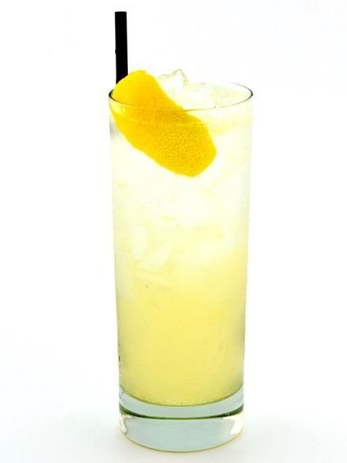

|  |  |
| --- | --- |
| **QUANTITY** | **INGREDIENTS:** |
| 1 fl oz | Simple Syrup |
| 1 fl oz | Fresh Lemon Juice |
| 1 fl oz | Spirit of Choice (Gin, Vodka, Whiskey, etc.) |
| 4 fl oz * | Soda Water *(fill with soda approximate volume) |

**RECIPE:**

1. Pack a Collins glass full of ice.

2. Measure 1 fl oz Simple Syrup, 1 fl oz Lemon Juice, 1 fl oz of Chosen

Spirit and pour over ice.

3. Top with 4 fl oz of Soda Water.

4. Insert bar spoon and stir to thoroughly mix ingredients.

5. Top with ice level with the rim of the glass.

6. Garnish with a Lemon Zest.

7. Add 8” Straw

**DOUBLE:** Add 1 fl oz of the spirit of choice

**ALTERNATE VARIATIONS:**

1. Tom Collins = Gin

2. John Collins = Whiskey

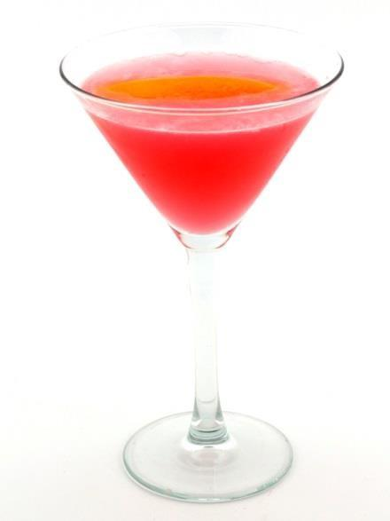

|  |  |
| --- | --- |
| **QUANTITY** | **INGREDIENTS:** |
| 0.5 fl oz | Simple Syrup |
| 0.5 fl oz | Fresh Lime Juice |
| 2 fl oz | Cranberry Juice |
| 0.5 fl oz | Triple Sec |
| 1.5 fl oz | Citrus Vodka |

**RECIPE:**

1. In a Mixing glass, measure 0.5 fl oz Simple Syrup, 0.5 fl oz Fresh Lime Juice, 2 fl oz Cranberry Juice, 1.5 fl oz Citrus Vodka, and 0.5 fl oz Triple Sec.

2. Pack Mixing glass full with ice. Top with a stainless steel shaking tin.

3. Pack Martini Glass full with ice and top with soda water to chill glass.

4. Shake vigorously 12 times to mix ingredients.

5. Empty chilling ice and soda from Martini Glass into dump sink.

6. Strain into a chilled Martini glass

7. Garnish with an Orange Zest

**DOUBLE:** Add 0.5 fl oz Citrus Vodka & 0.5 fl oz Triple Sec

**FUN FACT:** What started as a cocktail launch in the 80’s by ocean spray was reinvented by Cheryl Charming in Florida by adding citrus vodka following the launch of Absolut in North America. Then in the late 80’s Dale Degroff perfected the drink by substituting roses lime with real lime juice.

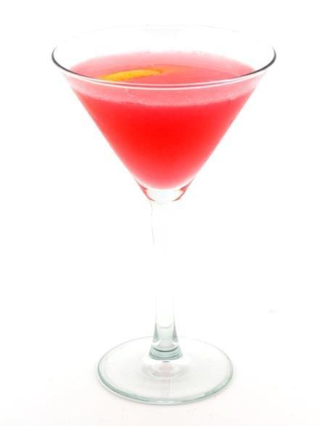

|  |  |
| --- | --- |
| **QUANTITY** | **INGREDIENTS:** |
| 3 fl oz | Cranberry Juice |
| 2 fl oz | Well Vodka |

**RECIPE:**

1. In a Mixing glass, measure 3 fl oz Cranberry Juice and 2 fl oz Well

Vodka.

2. Pack Mixing glass full with ice. Top with a stainless steel shaking tin.

3. Pack Martini Glass full with ice and top with soda water to chill glass.

4. Shake vigorously 12 times to mix ingredients.

5. Empty chilling ice and soda from Martini Glass into dump sink.

6. Strain into a chilled Martini glass

7. Garnish with a Lemon Zest

**DOUBLE:** Add 1 fl oz Well Vodka

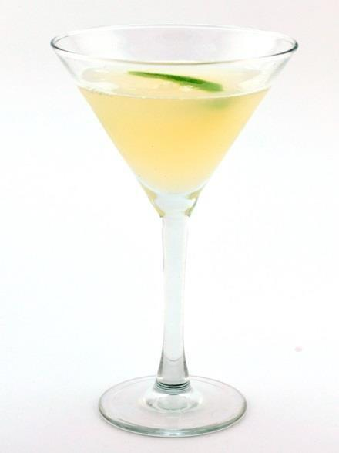

|  |  |
| --- | --- |
| **QUANTITY** | **INGREDIENTS:** |
| 1 fl oz | Simple Syrup |
| 1 fl oz | Fresh Lime Juice |
| 1 fl oz | Water |
| 1 fl oz | Well White Rum |

**RECIPE:**

1. In a Mixing glass, measure 1 fl oz Simple Syrup, 1 fl oz Fresh Lime

Juice, 1 fl oz Water and 1 fl oz Well White Rum.

2. Pack Mixing glass full with ice. Top with a stainless steel shaking tin.

3. Pack Martini Glass full with ice and top with soda water to chill glass.

4. Shake vigorously 12 times to mix ingredients.

5. Empty chilling ice and soda from Martini Glass into dump sink.

6. Strain into a chilled Martini glass

7. Garnish with a Wide Lime Zest

**DOUBLE: REPLACE WATER** with 1 fl oz Well White Rum

**FUN FACT:** Invented in 1898 in Cuba by both Harry E. Stout and Jennings Cox in the town of Daiquiri. Not much of an invention but the addition of the newest cocktail ingredient, ice, mixed with the local hooch, rum.



|  |  |
| --- | --- |
| **QUANTITY** | **INGREDIENTS:** |
| 1 fl oz | Simple Syrup |
| 1 fl oz | Fresh Lime Juice |
| 1 fl oz | Water |
| 1 fl oz | Spirit of Choice (Gin, Vodka, Whiskey, etc.) |

**RECIPE:**

1. In a mixing glass, measure 1 fl oz Syrup, 1 fl oz Fresh Lime Juice, 1 fl oz Water, and 1 fl oz Chosen Spirit,

2. Pack mixing glass full with ice. Top with a stainless steel shaking tin.

3. Pack Martini Glass full with ice and top with soda water to chill glass.

4. Shake vigorously 12 times to mix ingredients.

5. Empty chilling ice and soda from Martini Glass into dump sink.

6. Strain into a chilled martini glass.

7. Garnish with a Lime Zest

**DOUBLE: REPLACE WATER** with 1 fl oz Spirit of Choice

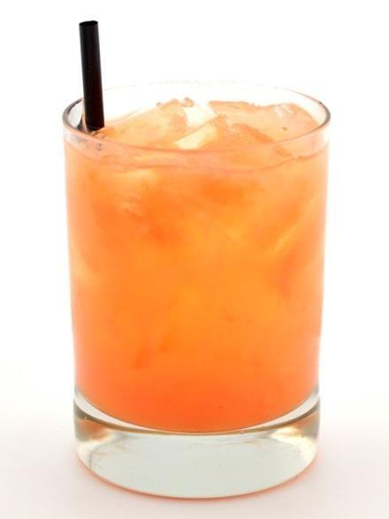

|  |  |
| --- | --- |
| **QUANTITY** | **INGREDIENTS:** |
| 4 fl oz | Grapefruit Juice |
| 1 fl oz | Well Vodka |

**RECIPE:**

1. Pack a Double Rocks glass full of ice.

2. Measure 4 fl oz Grapefruit Juice and 1 fl oz Well Vodka and pour over ice.

3. Add a 6” Straw.

**DOUBLE:** Add 1 fl oz Well Vodka

**FUN FACT:** By adding a salted rim a greyhound becomes a “Salty Dog”

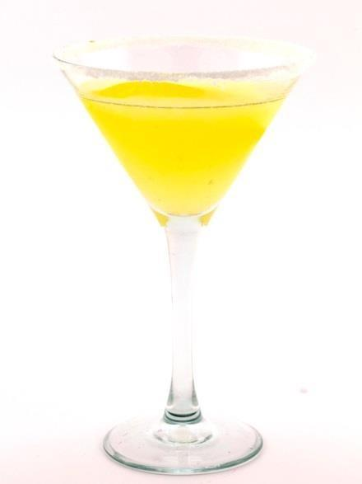

|  |  |
| --- | --- |
| **QUANTITY** | **INGREDIENTS:** |
| 1 fl oz | Simple Syrup |
| 1.5 fl oz | Fresh Lemon Juice |
| 2 fl oz | Citrus Vodka |

**RECIPE:**

1. In a Mixing glass, measure1 fl oz Simple Syrup, 1.5 fl oz Fresh Lemon

Juice, and 2 fl oz Citrus Vodka.

2. Pack Mixing glass full with ice. Top with a stainless steel shaking tin.

3. Pack Martini Glass full with ice and top with soda water to chill glass.

4. Shake vigorously 12 times to mix ingredients.

5. Empty chilling ice and soda from Martini Glass into dump sink.

6. Rim Martini Glass with Sugar

7. Strain into a chilled Martini glass with a White Sugar rim.

8. Garnish with a Lemon Zest.

**DOUBLE:** Add 1 fl oz Citrus Vodka

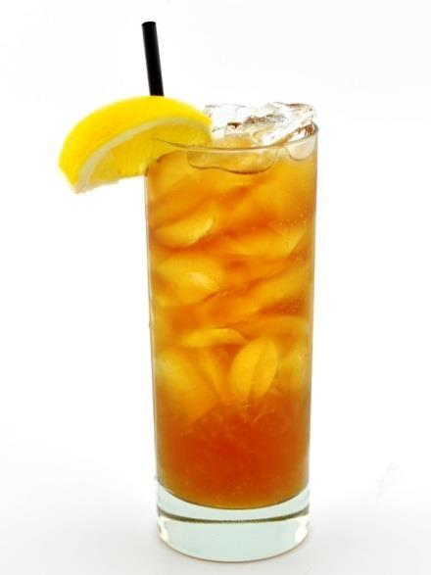

|  |  |
| --- | --- |
| **QUANTITY** | **INGREDIENTS:** |
| 1 fl oz | Long Island Iced Tea Liqueur |
| 1 fl oz | Simple Syrup |
| 1 fl oz | Lemon Juice |
| 2 fl oz * | Coke *(fill half with coke approximate volume) |
| 2 fl oz * | Soda *(fill half with soda approximate volume) |

**RECIPE:**

1. Pack a Collins glass full of ice.

2. Measure 1 fl oz Long Island Iced Tea Liqueur, 1 fl oz Simple Syrup, 1 fl oz Lemon Juice and 2 fl oz Coke + 2 fl oz soda and pour over ice.

3. Insert bar spoon and stir to thoroughly mix ingredients.

4. Top with ice level with the rim of the glass.

5. Garnish with a Lemon Wedge

6. Add 8” Straw.

**DOUBLE:** Add 1 fl oz Long Island Iced Tea Liqueur

**FUN FACT:** This drink is rumored to be invented in Long Island by wives who while their husbands were off at work would mix a little of everything from the liqueur cabinet and disguise it as iced tea.

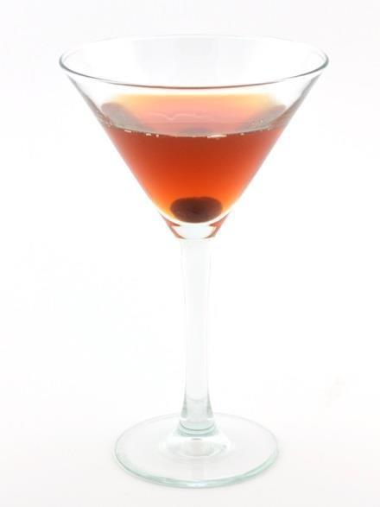

|  |  |
| --- | --- |
| **QUANTITY** | **INGREDIENTS:** |
| 1.5 fl oz | Jim Beam (or whiskey of choice) |
| 0.5 fl oz | Sweet Vermouth |
| 2 dashes | Angostura Bitters |

**RECIPE:**

1. In a Mixing glass; measure 1.5 fl oz Jim Beam, 0.5 fl oz Sweet

Vermouth and 2 dashes Angostura Bitters.

2. Pack Mixing glass full of ice.

3. Pack Martini Glass full with ice and top with soda water to chill glass.

4. Insert Bar Spoon and stir in circles for 20 seconds.

5. Empty chilling ice and soda from Martini Glass into dump sink.

6. Top with a Julep Strainer without removing spoon and strain into a chilled Martini glass.

7. Garnish with a Cherry.

**DOUBLE:** Add 0.5 fl oz Jim Beam, 0.5 oz Sweet Vermouth & 1 dash of bitters.

**ALTERNATE VARIATIONS:**

1. Dry Manhattan = Substitute Dry Vermouth for the Sweet

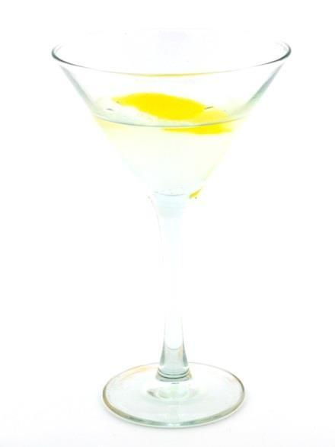

|  |  |
| --- | --- |
| **QUANTITY** | **INGREDIENTS:** |
| 2 fl oz | Gin of Choice |
| 0.25 fl oz | Dry Vermouth |

**RECIPE:**

1. In a Mixing glass; measure 2 fl oz Gin and 0.25 Dry Vermouth.

2. Pack the Mixing glass full of ice.

3. Pack Martini Glass full with ice and top with soda water to chill glass.

4. Insert Bar Spoon and stir in circles for 20 seconds.

5. Empty chilling ice and soda from Martini Glass into dump sink.

6. Top with a Julep Strainer without removing spoon and strain into a chilled martini glass

7. Garnish with a Lemon Zest or Olives

**DOUBLE:** Add 1 fl oz Gin

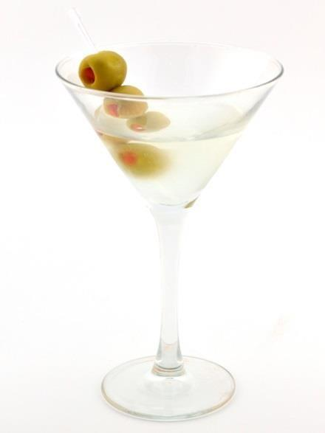

|  |  |
| --- | --- |
| **QUANTITY** | **INGREDIENTS:** |
| 2 fl oz | Vodka of Choice |
| Bar Spoon | Dry Vermouth |

**RECIPE:**

1. In a mixing glass; measure 2 fl oz Vodka and a Bar Spoon of Dry

Vermouth.

2. Pack the Mixing glass full of ice.

3. Pack Martini Glass full with ice and top with soda water to chill glass.

4. Insert Bar Spoon and stir in circles for 20 seconds.

5. Empty chilling ice and soda from Martini Glass into dump sink.

6. Top with a Julep Strainer without removing spoon and strain into a chilled martini glass.

7. Garnish with a Lemon Zest or Olives

**DOUBLE:** Add 1 fl oz Vodka and another dash of Dry Vermouth

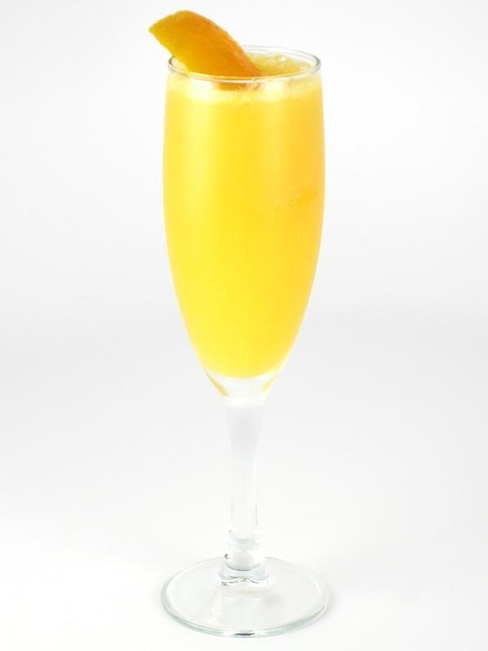

|  |  |
| --- | --- |
| **QUANTITY** | **INGREDIENTS:** |
| 4 fl oz | Lamarco Brut |
| 2 fl oz | Orange Juice |

**RECIPE:**

1. In a Flute measure 4 fl oz Lamarco Brut and top with 2 fl oz Orange

Juice.

2. Garnish with an orange zest.

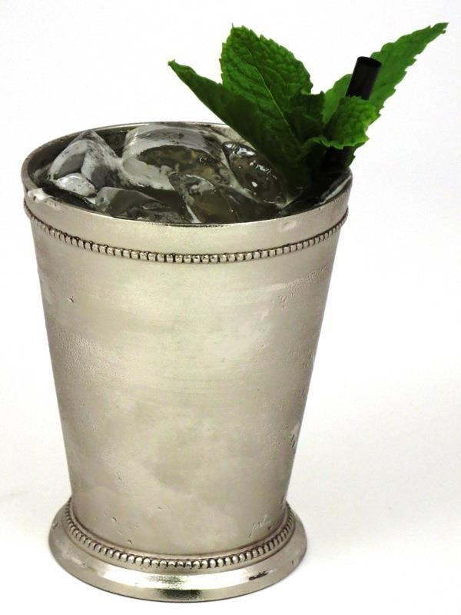

|  |  |
| --- | --- |
| **QUANTITY** | **INGREDIENTS:** |
| 10 – 12 | Mint Leaves |
| 0.25 fl ox | Simple Syrup |
| 2 fl oz | Jim Beam Bourbon |

**RECIPE:**

1. In a Mixing glass; measure 10 – 12 Mint Leaves, 0.25 fl oz Simple

Syrup and 2 fl oz Jim Beam.

2. Muddle gently to release oils.

3. Pack Mixing glass (**3/4** FULL) of fresh ice.

4. Insert Bar Spoon and stir in circles for 20 seconds.

5. Pour entire contents into a Julep Cup.

6. Top with ice level with the rim of the glass.

7. Add a 6” Straw

**DOUBLE:** Add 1 fl oz Jim Beam Bourbon

**FUN FACT:** The Julep has been speculated to date back to the early 1700’s but first was in print in 1803 described as "dram of spirituous liquor that has mint in it, taken by Virginians in the morning."

Most likely this drinks lineage connects it to an Arab drink called Julab that was made with water and rose petals that when made its way to the Mediterranean was substituted for the plentiful mint shrubs. It officially

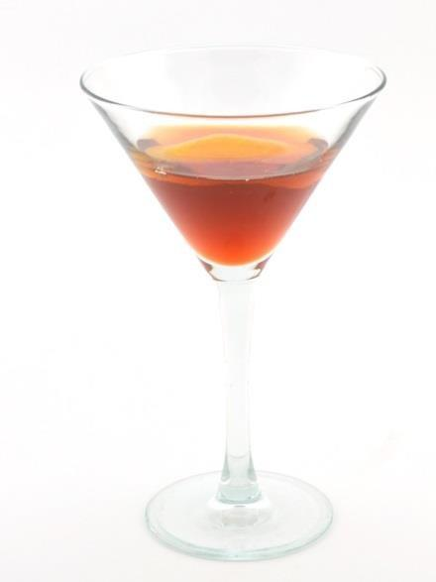

|  |  |
| --- | --- |
| **QUANTITY** | **INGREDIENTS:** |
| 0.75 fl oz | Well Gin |
| 0.75 fl oz | Campari |
| 0.75 fl oz | Sweet Vermouth |

**RECIPE:**

1. In a Mixing glass; measure 0.75 fl oz Well Gin, 0.75 fl oz Campari and 0.75 fl oz Sweet Vermouth.

2. Pack Mixing glass full of ice.

3. Pack Martini Glass full with ice and top with soda water to chill glass.

4. Insert Bar Spoon and stir in circles for 20 seconds.

5. Empty chilling ice and soda from Martini Glass into dump sink.

6. Top with a Julep Strainer without removing spoon and strain into a chilled Martini glass.

7. Garnish with a Orange Zest.

**DOUBLE:** Scale all ingredients up to 1 fl oz

**FUN FACT**: The Negroni was created in 1925 at the Hotel Baglioni when Count Camillo Negroni, a Florentine aristocrat, asked the bartender to add a kick to his Americano cocktail.

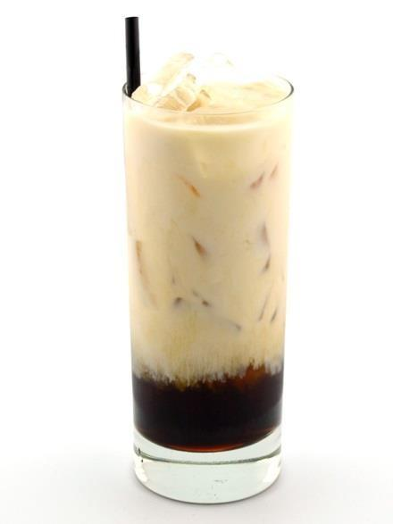

|  |  |
| --- | --- |
| **QUANTITY** | **INGREDIENTS:** |
| 0.5 fl oz | Well Vodka |
| 0.5 fl oz | Kahlua |
| 3 fl oz | Coke |
| 3 fl oz | Milk |

**RECIPE:**

1. Fill a Collins glass full with ice.

2. Measure 0.5 fl oz Well Vodka and 0.5 fl oz Kahlua over ice.

3. Measure 3 fl oz Coke into the Collins glass.

4. Top with 3 fl oz Milk slowly to avoid curdling.

5. Add 8” Straw.

**DOUBLE:** Add 0.5 fl oz Well Vodka & 0.5 fl oz Kahlua

**ALTERNATIVE VARIATION:**

**1.** Colorado Bulldog = substitute coke for soda water

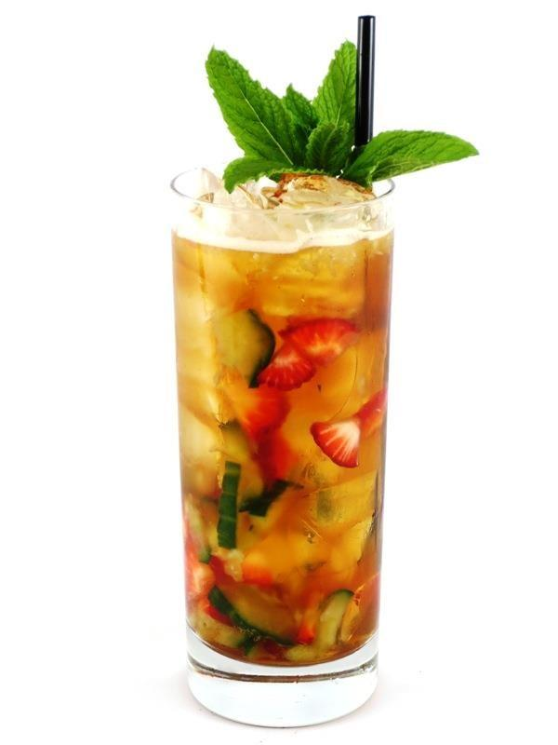

|  |  |
| --- | --- |
| **QUANTITY** | **INGREDIENTS:** |
| **PART A** |  |
| 1 oz | Cucumber Pieces |
| 1.5 fl oz | Pimms |
| 1 dash | Fee Brothers Orange Bitters |
| **PART B** |  |
| 1 oz | Strawberry Pieces |
| 4 fl oz* | Ginger Ale (*approx volume, fill with Ginger Ale) |

**RECIPE:**

1. In a Collins Glass measure 1 oz Cucumber Pieces, 1.5 fl oz Pimms and

1 dash Fee Brothers Orange Bitters.

2. Muddle.

3. Add 1 oz Strawberry Pieces

4. Pack Collins glass **full** of ice.

5. Top with 4 fl oz Ginger Ale.

6. Insert bar spoon and stir to thoroughly mix ingredients.

7. Top with ice level with the rim of the glass.

8. Garnish with a Mint Sprig.

9. Add 8” Straw.

**DOUBLE:** Add 1 fl oz Pimms

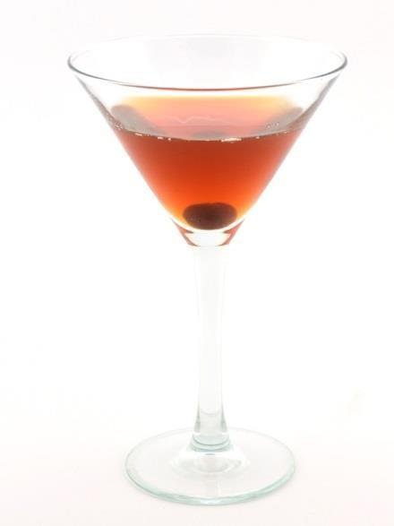

|  |  |
| --- | --- |
| **QUANTITY** | **INGREDIENTS:** |
| 1.5 fl oz | Blended Scotch Whisky |
| 0.5 fl oz | Sweet Vermouth |
| 2 dashes | Angostura Bitters |

**RECIPE:**

1. In a Mixing glass; measure 1.5 fl oz Blended Scotch,

0.5 fl oz Sweet Vermouth and 2 dashes Angostura Bitters.

2. Pack Mixing glass full of ice.

3. Pack Martini Glass full with ice and top with soda water to chill glass.

4. Insert Bar Spoon and stir in circles for 20 seconds.

5. Empty chilling ice and soda from Martini Glass into dump sink.

6. Top with a Julep Strainer without removing spoon and strain into a chilled martini glass.

7. Garnish with a Cherry.

**DOUBLE:** Add 0.5 fl oz Blended Scotch, 0.5 oz Sweet Vermouth

& 1 dash of bitters.

**ALTERNATE VARIATIONS:**

3. Dry = Substitute Dry Vermouth for the Sweet

4. Perfect = 0.25 fl oz both Sweet and Dry Vermouth

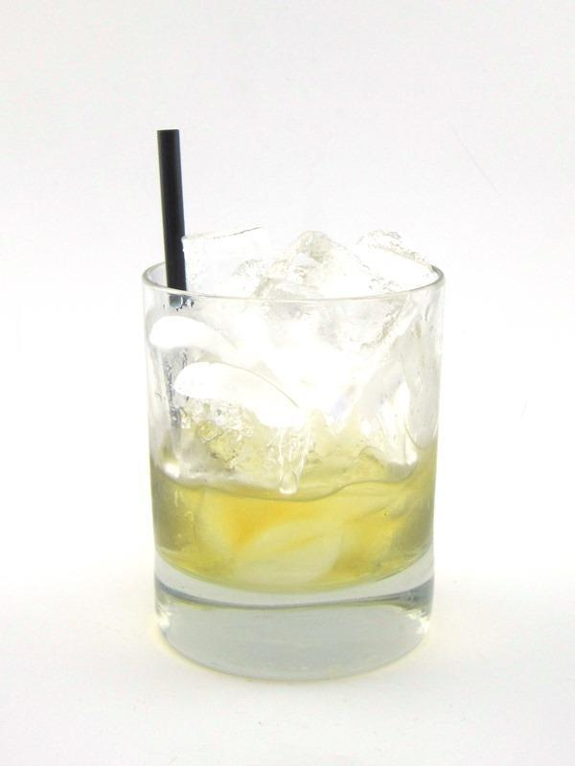

|  |  |
| --- | --- |
| **QUANTITY** | **INGREDIENTS:** |
| 0.5 fl oz | Blended Scotch |
| 0.5 fl oz | Drambuie |

**RECIPE:**

1. Pack a Small Rocks glass full of ice.

2. Measure 0.5 fl oz Blended Scotch and 0.5 fl oz

Drambuie and pour over ice.

3. Add a 6” Straw.

**DOUBLE:** Add 0.5 fl oz Blended Scotch & 0.5 fl oz Drambuie

**FUN FACT**: This cocktail went through a barrage of name changes through

the 20’s, 30’s and 40’s before the name rusty nail stuck most likely form the

21 club in New York. Its popularity is credited to Playboy for publishing it.

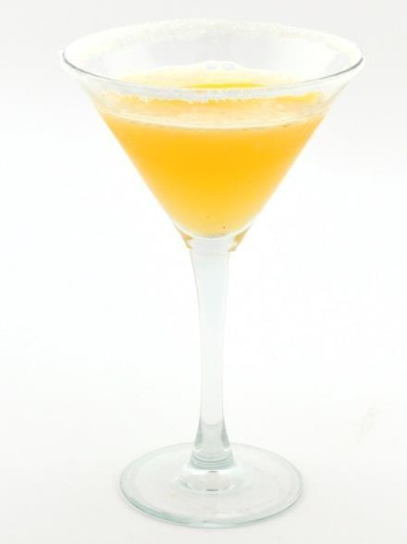

|  |  |
| --- | --- |
| **QUANTITY** | **INGREDIENTS:** |
| 0.75 fl oz | Lemon Juice |
| 1 fl oz | Water |
| 1 fl oz | Triple Sec |
| 1 fl oz | Brandy |

**RECIPE:**

1. In a Mixing glass, measure 0.75 fl oz Lemon Juice 1 fl oz Water, 1 fl oz

Brandy and 1 fl oz Triple Sec.

2. Pack Mixing glass full with ice. Top with a stainless steel shaking tin.

3. Pack Martini Glass full with ice and top with soda water to chill glass.

4. Shake vigorously 12 times to mix ingredients.

5. Empty chilling ice and soda from Martini Glass into dump sink.

6. Rim Martini Glass with Sugar

7. Strain into a chilled Martini glass rimmed with Sugar.

8. Garnish with a Lemon Zest.

**DOUBLE: REMOVE WATER** and add 1 fl oz Brandy

**FUN FACT:** The side car dates back to WW1 when a cold customer arrived at Harry’s Bar in Paris after riding his motorcycle requesting a libation to warm him up. This is a variation of a brandy crusta

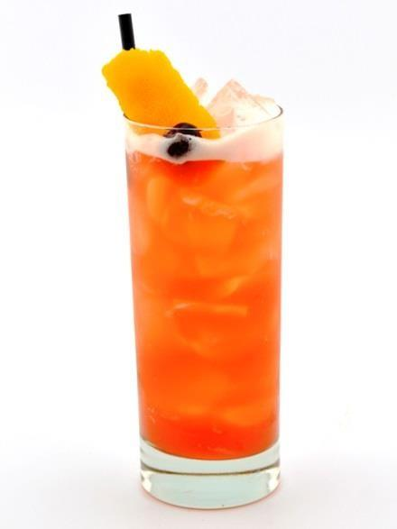

|  |  |
| --- | --- |
| **QUANTITY** | **INGREDIENTS:** |
| 3 fl oz | Pineapple Juice |
| 0.5 fl oz | Fresh Lime Juice |
| 0.25 fl oz | Grenadine |
| 1 fl oz | Well Gin |
| 0.5 fl oz | Cherry Liqueur (or Raspberry Liqueur) |
| 0.25 fl oz | Triple Sec |
| 0.25 fl oz | Benedictine |
| 1 dash | Angostura Bitters |

**RECIPE:**

1. In a Mixing glass, measure 4 fl oz Pineapple, 0.5 fl oz Lime Juice, 0.25 fl oz Grenadine, 1 fl oz Well Gin, 0.5 fl oz Cherry Liqueur, 0.25 fl oz Triple Sec, 0.25 fl oz Benedictine and 1 dash Angostura Bitters.

2. Pack Mixing glass full with ice. Top with a stainless steel shaking tin.

3. Shake vigorously 12 times to mix ingredients.

4. Strain over fresh ice into a Collins glass.

5. Garnish with an Orange Peel and a Cherry.

6. Add an 8” Straw.

**DOUBLE:** Add 0.5 fl oz Well Gin & 0.5 fl oz Triple Sec

**FUN FACT:** Ngiam Tong Boon created the Singapore Sling at the Raffles Hotel in Singapore sometime between 1910 and 1915. While the original recipe is lost, it first appeared in print in 1922 "Cocktails and How to Make them" by Jenkins. The drink was originally named the Straights Sling, changed to the Singapore Sling in the 40's then modified by Ngiam's nephew

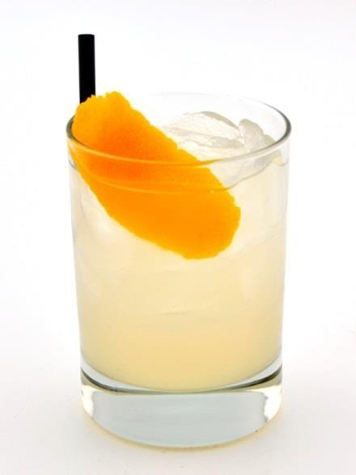

|  |  |
| --- | --- |
| **QUANTITY** | **INGREDIENTS:** |
| 1 fl oz | Simple Syrup |
| 1 fl oz | Lemon Juice |
| 1 fl oz | Water |
| 1 fl oz | Spirit of Choice (vodka, whiskey, amaretto, etc.) |

**RECIPE:**

1. In a Mixing glass, measure 1 fl oz Lemon Juice, 1 fl oz Simple Syrup, 1 fl oz Water and 1 fl oz Booze.

2. Pack Mixing glass full with ice. Top with a stainless steel shaking tin.

3. Shake vigorously 12 times to mix ingredients.

4. Strain over fresh ice into a Double Rocks glass.

5. Garnish with Lemon Zest and add a 6” Straw.

This standard “sour” template that can be used for multiple applications; It eliminates the confusion of memorizing multiple recipes for similar styles of drinks. This “sour template” is used for margaritas, daiquiris, sidecars, and any sours including gin, whiskey and amaretto. This template works well for two reasons. First; the equal proportions of citrus to syrup are a tried and true ratio to create a perfect balance of sweet to sour. Second; it is easily

translated from 1oz to 2oz because water acts as an inert liquid that dilutes the finished product to the desired result. By substituting water with double the base spirit you are enhancing the taste of the spirit and doubling the

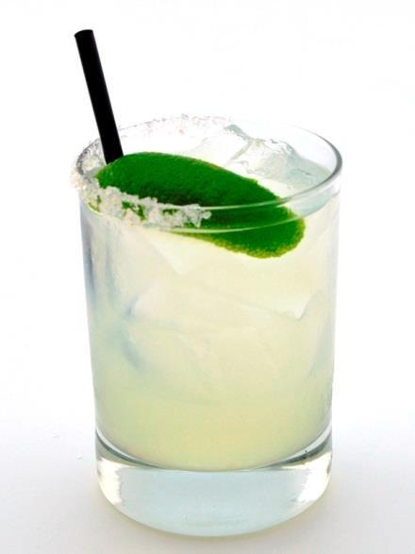

|  |  |
| --- | --- |
| **QUANTITY** | **INGREDIENTS:** |
| 1 fl oz | Agave Nectar |
| 1 fl oz | Fresh Lime Juice |
| 2 fl oz | Well Tequila |

**RECIPE:**

1. Rim Double Rocks glass with a ½ rim of Margarita Salt and fill with ice.

2. In a mixing glass, measure 1 fl oz Agave Nectar, 1 fl oz Fresh Lime

Juice 2 fl oz Well Tequila.

3. Pack Mixing glass full with ice. Top with a stainless steel shaking tin.

4. Shake vigorously 12 times to mix ingredients.

5. Strain over fresh ice into the ½ salt rimmed

6. Double Rocks glass full of ice.

7. Garnish with Lime Zest.

8. Add 6” Straw.

**DOUBLE:** Add 1 fl oz Well Tequila

**FUN FACT:** Invented at Tommy’s Mexican restaurant in San Francisco, this

variation of a traditional rocks margarita uses only 100% agave herradura

el jimador reposado tequila that is shaken with pure agave nectar and fresh lime juice.

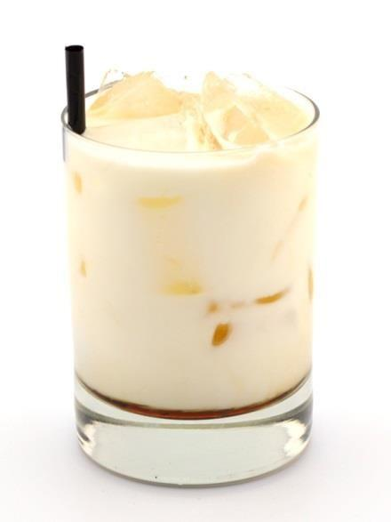

|  |  |
| --- | --- |
| **QUANTITY** | **INGREDIENTS:** |
| 0.5 fl oz | Well Vodka |
| 0.5 fl oz | Kahlua |
| 4 fl oz | Milk |

**RECIPE:**

1. Pack a Double Rocks glass full of ice.

2. Measure 0.5 fl oz Well Vodka, 0.5 fl oz Kahlua and 4 fl oz

Milk and pour over ice.

3. Add a 6” Straw.

**DOUBLE:** Add 0.5 fl oz Well Vodka & 0.5 fl oz Kahlua

**FUN FACT**: Created in 1949 in Belgium by a bartender at the Hotel Metropole, the Black Russian is not a traditional Russian drink, but rather a pun on the name of the anti-Bolshevic “White Russians” from the Russian Civil War. The addition of Milk makes it a white Russian.

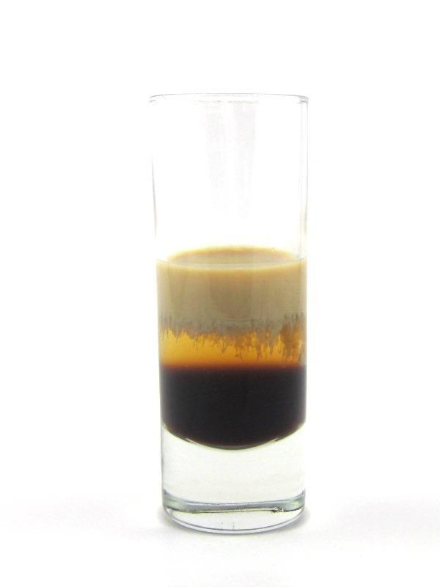

|  |  |
| --- | --- |
| **QUANTITY** | **INGREDIENTS:** |
| 0.33 fl oz | Kahlua |
| 0.33 fl oz | Crème de Menthe |
| 0.33 fl oz | Baileys |

**RECIPE:**

1. Measure 0.33 fl oz Kahlua into a 2 oz Shot Glass then layer 0.33 fl oz Crème de Menthe on top of Kahlua then layer 0.33 fl oz Baileys on top of Crème de Menthe.

2. Serve.

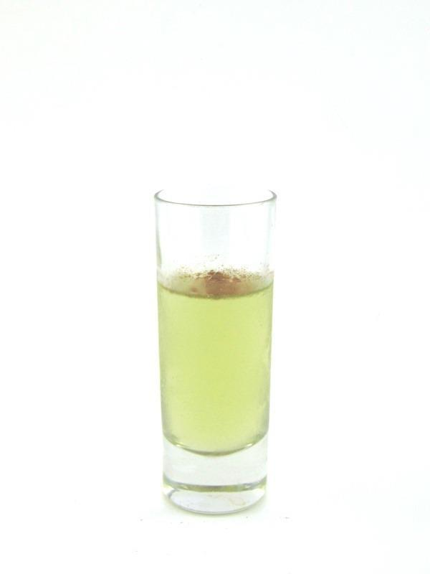

|  |  |
| --- | --- |
| **QUANTITY** | **INGREDIENTS:** |
| 0.5 fl oz | Butter Ripple |
| 0.5 fl oz | Sour Puss Apple |

**RECIPE:**

1. Measure 0.5 fl oz Butter Ripple and 0.5 fl oz Sour Puss Apple into a 2 oz Shot Glass.

2. Sprinkle a dash of Cinnamon on top.

3. Serve.

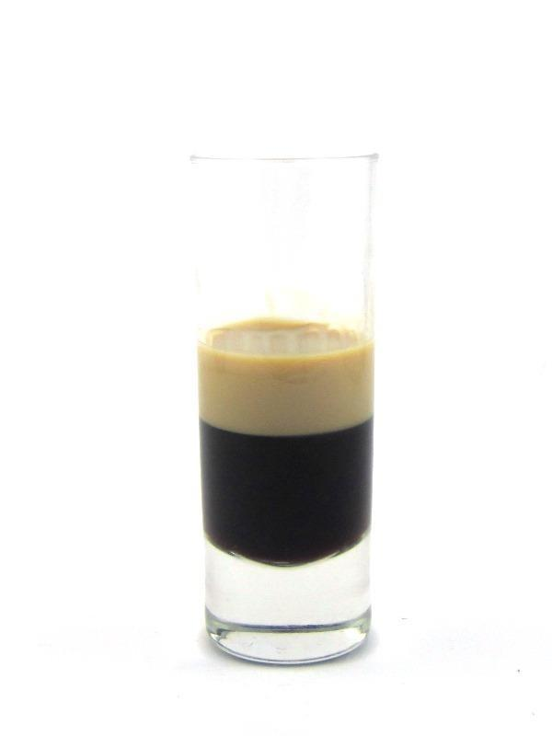

|  |  |
| --- | --- |
| **QUANTITY** | **INGREDIENTS:** |
| 0.75 fl oz | Kahlua |
| 0.25 fl oz | Baileys |

**RECIPE:**

1. Measure 0.75 fl oz Kahlua into a 2 oz Shot Glass then layer 0.25 fl oz

Baileys on top of Kahlua.

2. Serve.

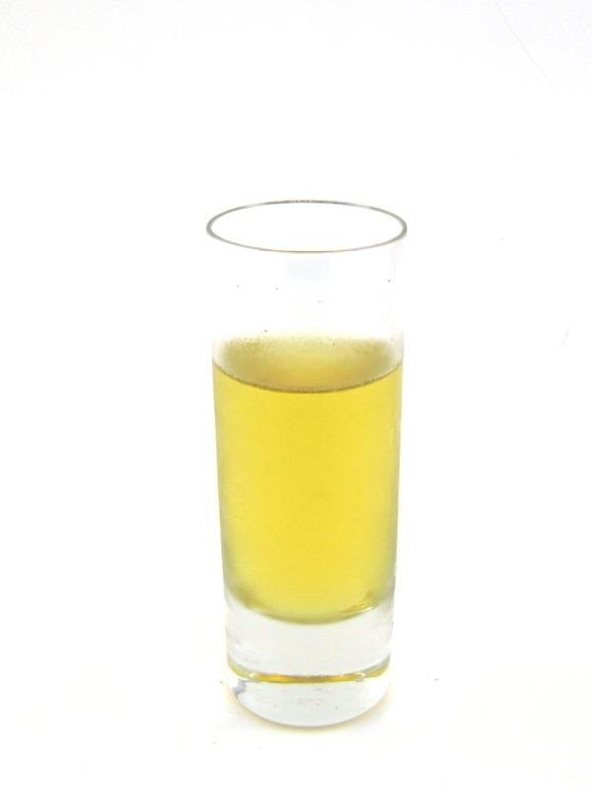

|  |  |
| --- | --- |
| **QUANTITY** | **INGREDIENTS:** |
| 0.5 fl oz | Jack Daniels |
| 0.5 fl oz | Banana Liqueur |

**RECIPE:**

1. In a Mixing Glass, measure 0.5 fl oz Jack Daniels and 0.5 fl oz Banana

Liqueur.

2. Pack Mixing glass full of ice. Top with a stainless steel shaking tin.

3. Shake vigorously 12 times to chill the ingredients.

4. Strain into a 2 oz shot glass.

5. Serve.

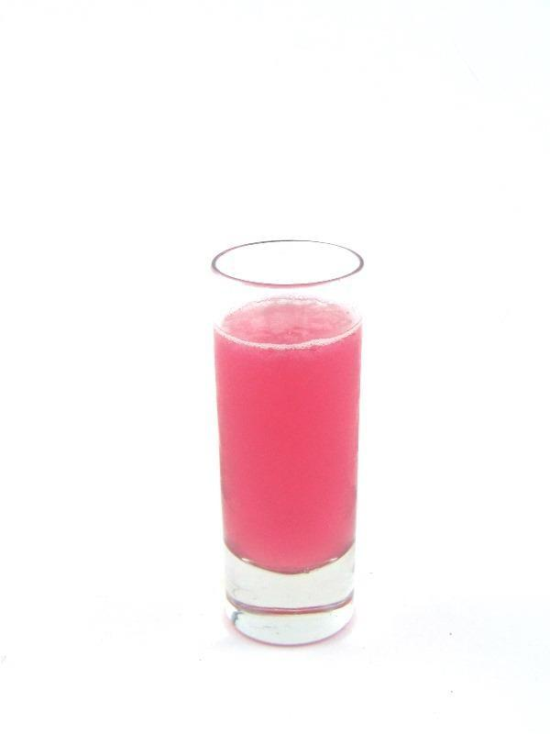

|  |  |
| --- | --- |
| **QUANTITY** | **INGREDIENTS:** |
| 0.5 fl oz | Well Vodka |
| 0.5 fl oz | Sour Puss Raspberry |
| 0.25 fl oz | Lime Juice |

**RECIPE:**

1. In a Mixing Glass, measure 0.5 fl oz Well Vodka, 0.5 fl oz Sour

Puss Raspberry and 0.25 fl oz Lime Juice.

2. Pack Mixing glass full of ice. Top with a stainless steel shaking tin.

3. Shake vigorously 12 times to chill the ingredients.

4. Strain into a 2 oz shot glass.

5. Serve.

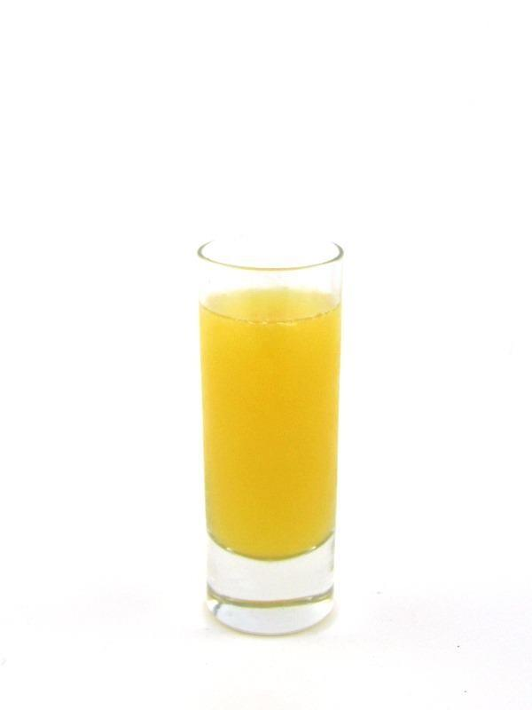

|  |  |
| --- | --- |
| **QUANTITY** | **INGREDIENTS:** |
| 0.5 fl oz | Grand Marnier |
| 0.5 fl oz | Peach Schnapps |
| 0.5 fl oz | Orange Juice |

**RECIPE:**

1. In a Mixing Glass, measure 0.5 fl oz Grand Marnier, 0.5 fl oz Peach

Schnapps and 0.5 fl oz Orange Juice.

2. Pack Mixing glass full of ice. Top with a stainless steel shaking tin.

3. Shake vigorously 12 times to chill the ingredients.

4. Strain into a 2 oz shot glass.

5. Serve.

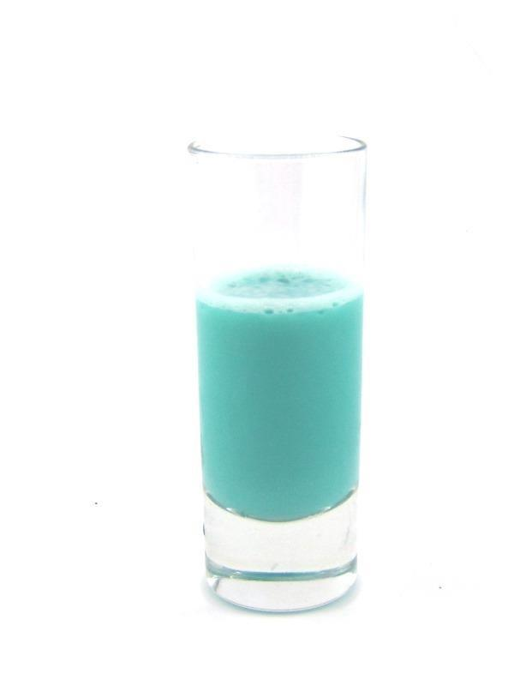

|  |  |
| --- | --- |
| **QUANTITY** | **INGREDIENTS:** |
| 0.33 fl oz | Baileys |
| 0.33 fl oz | Blue Curacao |
| 0.33 fl oz | Banana Liqueur |

**RECIPE:**

1. In a Mixing Glass, measure 0.33 fl oz Baileys, 0.33 fl oz Blue Curacao and 0.33 fl oz Banana Liqueur.

2. Pack Mixing glass full of ice. Top with a stainless steel shaking tin.

3. Shake vigorously 12 times to chill the ingredients.

4. Strain into a 2 oz shot glass.

5. Serve.

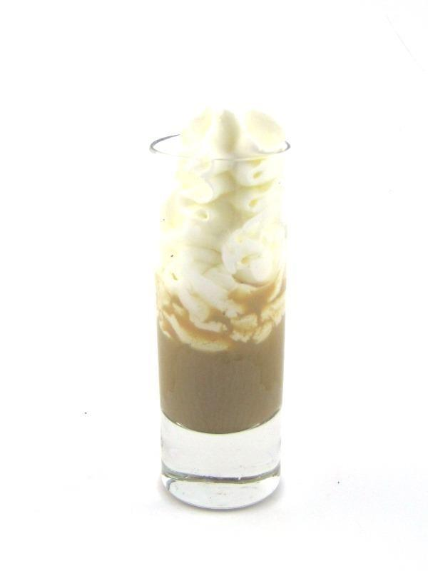

|  |  |
| --- | --- |
| **QUANTITY** | **INGREDIENTS:** |
| 0.5 fl oz | Kahlua |
| 0.5 fl oz | Baileys |

**RECIPE:**

1. Measure 0.5 fl oz Kahlua and 0.5 fl oz Baileys into a 2 oz Shot Glass.

2. Top with Whipped Cream.

3. Serve.

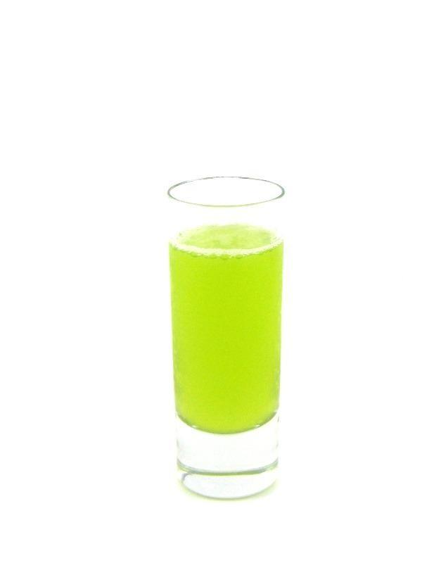

|  |  |
| --- | --- |
| **QUANTITY** | **INGREDIENTS:** |
| 0.5 fl oz | Melon Liqueur |
| 0.5 fl oz | Amaretto |
| 0.25 fl oz | Lime Juice |

**RECIPE:**

1. In a Mixing Glass, measure 0.5 fl oz Melon Liqueur, 0.5 fl oz Amaretto and 0.25 fl oz of Lime Juice.

2. Pack Mixing glass full of ice. Top with a stainless steel shaking tin.

3. Shake vigorously 12 times to chill the ingredients.

4. Strain into a 2 oz shot glass.

5. Serve.

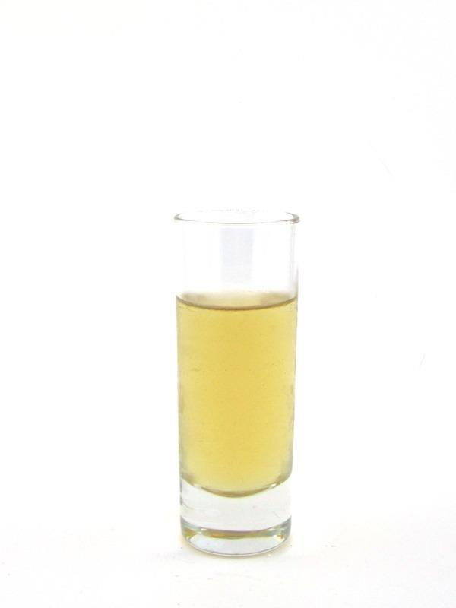

|  |  |
| --- | --- |
| **QUANTITY** | **INGREDIENTS:** |
| 0.5 fl oz | Captain Morgan’s Spiced Rum |
| 0.5 fl oz | Butter Ripple |

**RECIPE:**

1. In a Mixing Glass, measure 0.5 fl oz Captain Morgan’s Spiced Rum

and 0.5 fl oz Butter Ripple.

2. Pack Mixing glass full of ice. Top with a stainless steel shaking tin.

3. Shake vigorously 12 times to chill the ingredients.

4. Strain into a 2 oz shot glass.

5. Serve.

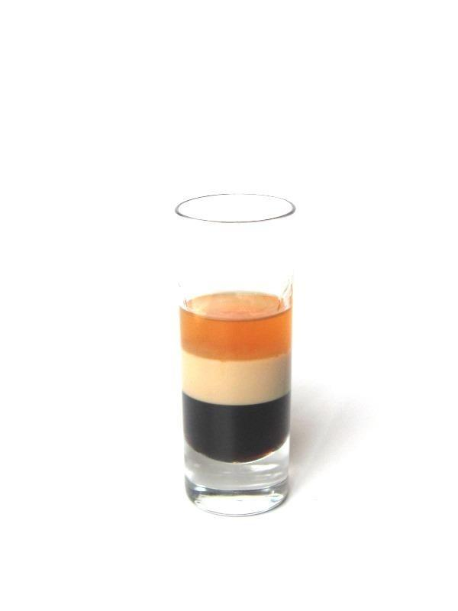

|  |  |
| --- | --- |
| **QUANTITY** | **INGREDIENTS:** |
| 0.33 fl oz | Kahlua |
| 0.33 fl oz | Baileys |
| 0.33 fl oz | Grand Marnier |

**RECIPE:**

1. Measure 0.33 fl oz Kahlua into a 2 oz Shot Glass then layer 0.33 fl oz Baileys on top of Kahlua then layer 0.33 fl oz Grand Marnier on top of Baileys.

2. Serve.

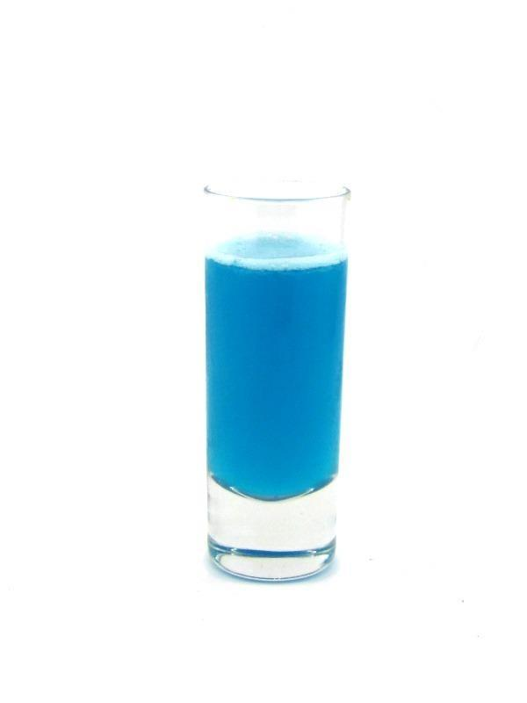

|  |  |
| --- | --- |
| **QUANTITY** | **INGREDIENTS:** |
| 0.5 fl oz | Malibu |
| 0.5 fl oz | Blue Curacao |
| 0.5 fl oz | Pineapple Juice |

**RECIPE:**

1. In a Mixing Glass, measure 0.5 fl oz Malibu, 0.5 fl oz Blue Curacao and 0.5 fl oz Pineapple Juice.

2. Pack Mixing glass full of ice. Top with a stainless steel shaking tin.

3. Shake vigorously 12 times to chill the ingredients.

4. Strain into a 2 oz shot glass.

5. Serve.

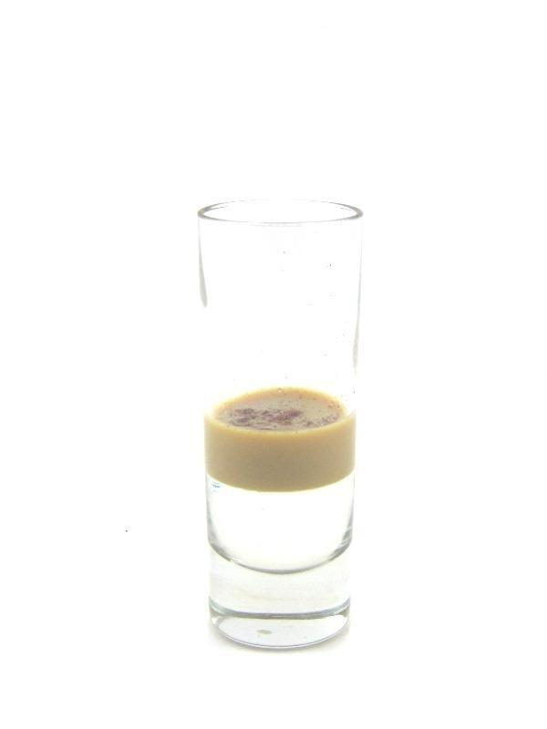

|  |  |
| --- | --- |
| **QUANTITY** | **INGREDIENTS:** |
| 0.5 fl oz | Crème de Cacao |
| 0.5 fl oz | Baileys |

**RECIPE:**

1. Measure 0.5 fl oz Crème de Cacao into a 2 oz Shot Glass then layer

0.5 fl oz Baileys on top of Crème de Cacao.

2. Sprinkle a dash of Cinnamon on top.

3. Serve.

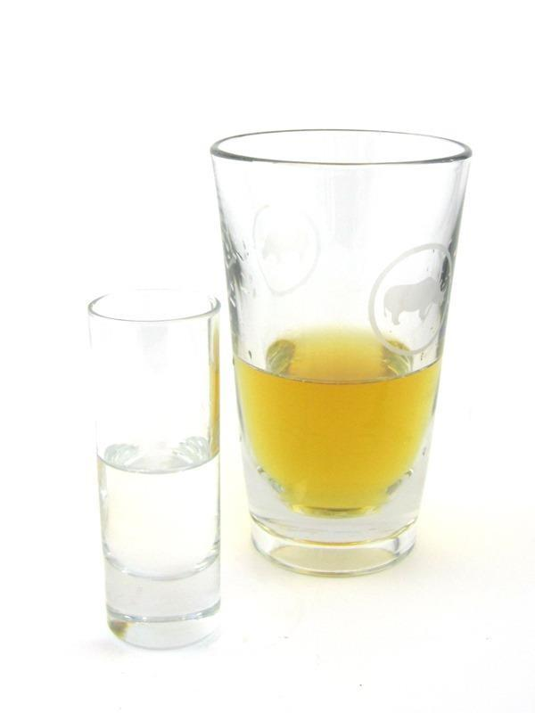

|  |  |
| --- | --- |
| **QUANTITY** | **INGREDIENTS:** |
| 1 fl oz | Orange Vodka |
| 3 fl oz | Red Bull |

**RECIPE:**

1. Measure 1 fl oz Orange Vodka oz into a 2 oz Shot Glass.

2. Measure 3 fl oz Red Bull into a Rhino Sleeve

3. Serve a shot and a sleeve side by side.

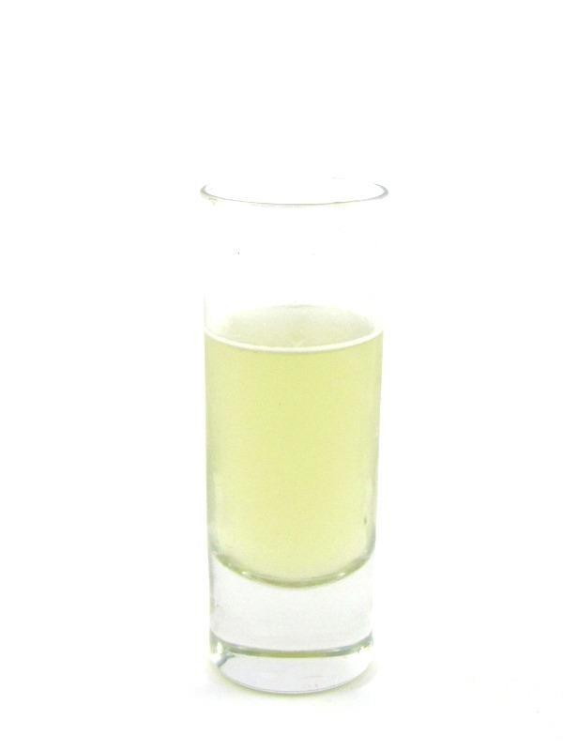

|  |  |
| --- | --- |
| **QUANTITY** | **INGREDIENTS:** |
| 0.5 fl oz | Crème de Cacao |
| 0.5 fl oz | Frangelico |

**RECIPE:**

1. In a Mixing Glass, measure 0.5 fl oz Crème de Cacao and 0.5 fl oz

Frangelico.

2. Pack Mixing glass full of ice. Top with a stainless steel shaking tin.

3. Shake vigorously 12 times to chill the ingredients.

4. Strain into a 2 oz shot glass.

5. Serve.

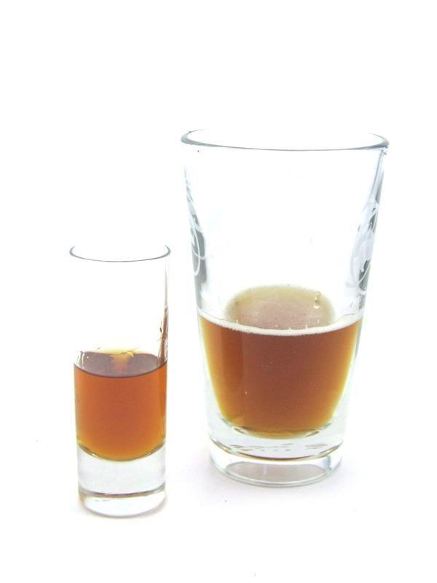

|  |  |
| --- | --- |
| **QUANTITY** | **INGREDIENTS:** |
| 1 fl oz | Amaretto |
| 3 fl oz | Pale Ale |

**RECIPE:**

1. Measure 1 fl oz into a 2 oz Shot Glass.

2. Measure 3 fl oz Pale Ale into a Sleeve.

3. Serve a shot and a sleeve side by side.

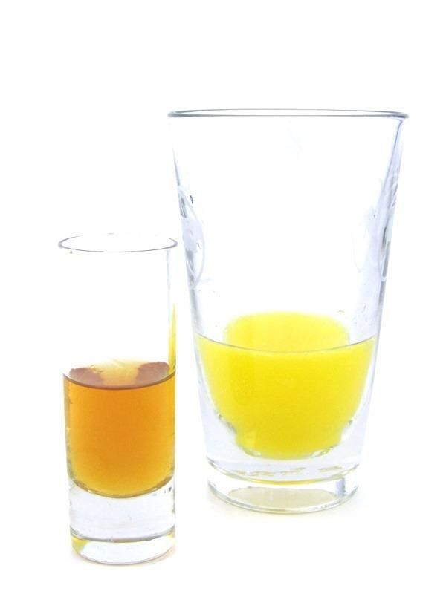

|  |  |
| --- | --- |
| **QUANTITY** | **INGREDIENTS:** |
| 0.5 fl oz | Amaretto |
| 0.5 fl oz | Southern Comfort |
| 1.5 fl oz | Orange Juice |
| 1.5 fl oz | Sprite |

**RECIPE:**

1. Measure 0.5 fl oz Amaretto and 0.5 fl oz Southern Comfort into a 2 oz

Shot Glass.

2. Measure 1.5 fl oz of Orange Juice and 1.5 fl oz of Sprite into a

Sleeve.

3. Serve a shot and a sleeve side by side.

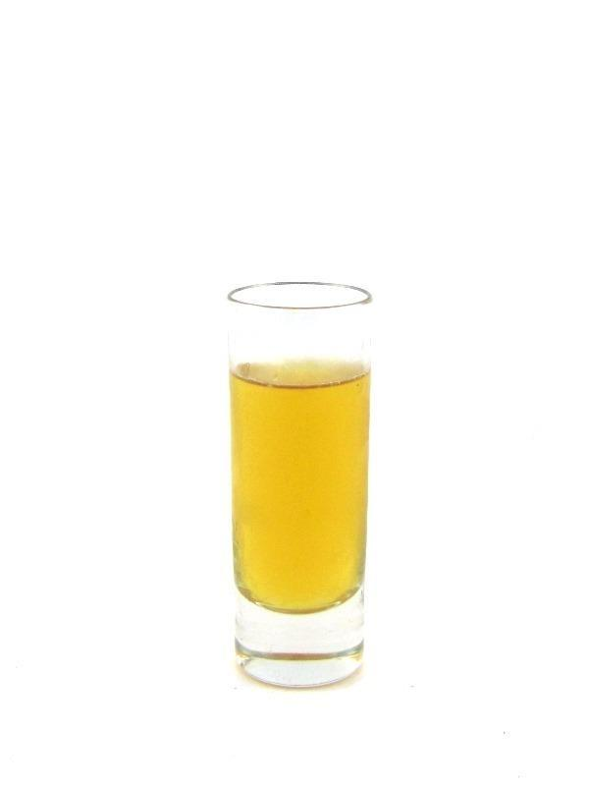

|  |  |
| --- | --- |
| **QUANTITY** | **INGREDIENTS:** |
| 0.5 fl oz | Blended Scotch |
| 0.5 fl oz | Amaretto |

**RECIPE:**

1. In a Mixing Glass, measure 0.5 fl oz Blended Scotch and 0.5 fl oz

Amaretto.

2. Pack Mixing glass full of ice. Top with a stainless steel shaking tin.

3. Shake vigorously 12 times to chill the ingredients.

4. Strain into a 2 oz shot glass.

5. Serve.

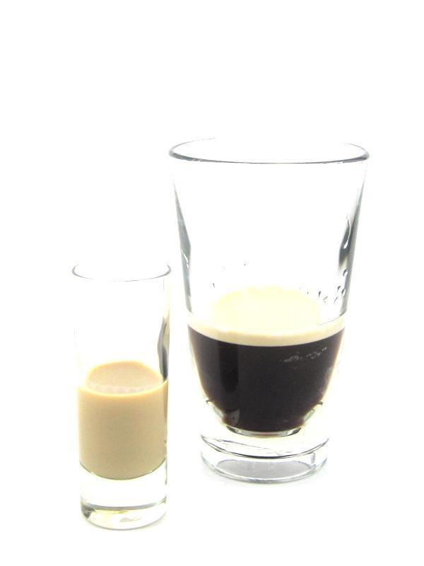

|  |  |
| --- | --- |
| **QUANTITY** | **INGREDIENTS:** |
| 1 fl oz | Baileys |
| 3 fl oz | Guinness |

**RECIPE:**

1. Measure 1 fl oz Baileys into a 2 oz Shot Glass.

2. Measure 3 fl oz Guinness into a Sleeve

3. Serve a shot and a sleeve side by side.



|  |  |
| --- | --- |
| **QUANTITY** | **INGREDIENTS:** |
| 0.5 fl oz | Crown Royal |
| 0.5 fl oz | Banana Liqueur |

**RECIPE:**

1. In a Mixing Glass, measure 0.5 fl oz Crown Royal and 0.5 fl oz Banana

Liqueur.

2. Pack Mixing glass full of ice. Top with a stainless steel shaking tin.

3. Shake vigorously 12 times to chill the ingredients.

4. Strain into a 2 oz shot glass.

5. Serve.

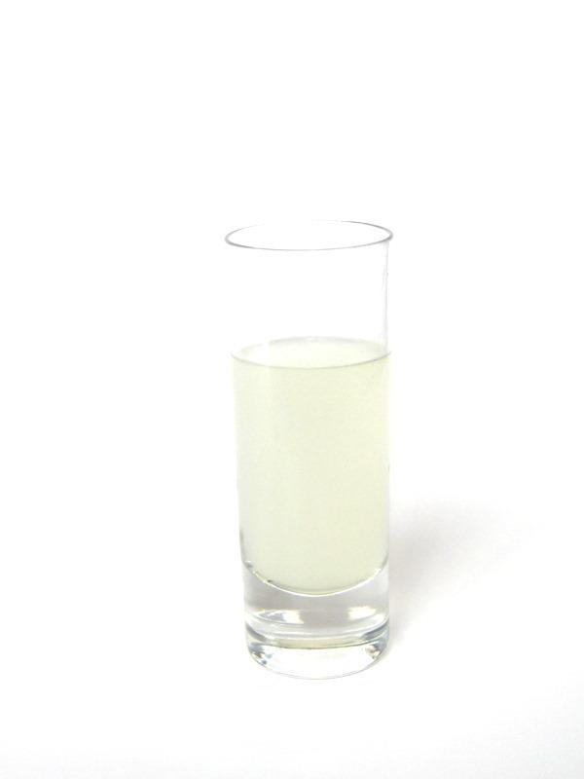

|  |  |
| --- | --- |
| **QUANTITY** | **INGREDIENTS:** |
| 0.5 fl oz | Triple Sec |
| 0.5 fl oz | Well Vodka |
| 0.25 fl oz | Lime Juice |

**RECIPE:**

1. In a Mixing Glass, measure 0.5 fl oz Triple Sec, 0.5 fl oz Well

Vodka and 0.25 fl oz Lime Juice.

2. Pack Mixing glass full of ice. Top with a stainless steel shaking tin.

3. Shake vigorously 12 times to chill the ingredients.

4. Strain into a 2 oz shot glass.

5. Serve.

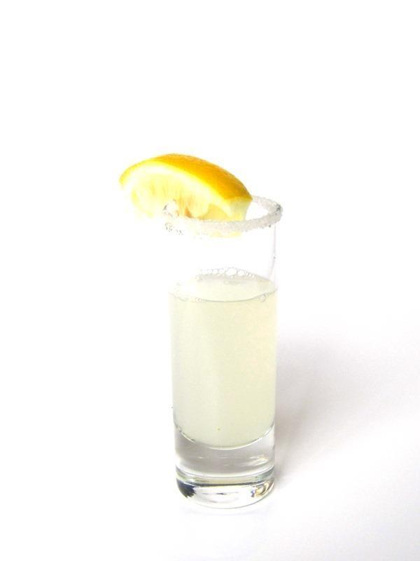

|  |  |
| --- | --- |
| **QUANTITY** | **INGREDIENTS:** |
| 0.5 fl oz | Citrus Vodka |
| 0.5 fl oz | Triple Sec |
| 0.25 fl oz | Lemon Juice |

**RECIPE:**

1. Rim a 2 oz shot glass with Sugar.

2. In a Mixing Glass, measure 0.5 fl oz Citrus Vodka, 0.5 fl oz

Triple Sec and 0.25 fl oz Lemon Juice.

3. Pack Mixing glass full of ice. Top with a stainless steel shaking tin.

4. Shake vigorously 12 times to chill the ingredients.

5. Strain into a Sugar rimmed 2 oz shot glass.

6. Garnish with a Lemon Wedge and Serve.

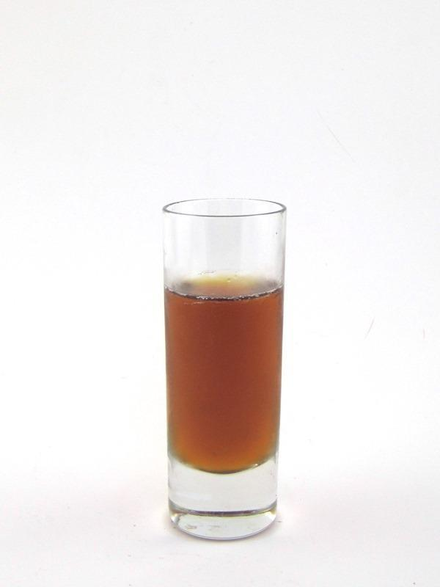

|  |  |
| --- | --- |
| **QUANTITY** | **INGREDIENTS:** |
| 0.5 fl oz | Jägermeister |
| 0.5 fl oz | Goldschlager |

**RECIPE:**

1. In a Mixing Glass, measure 0.5 fl oz Jägermeister and 0.5 fl oz

Goldschlager.

2. Pack Mixing glass full of ice. Top with a stainless steel shaking tin.

3. Shake vigorously 12 times to chill the ingredients.

4. Strain into a 2 oz shot glass.

5. Serve.

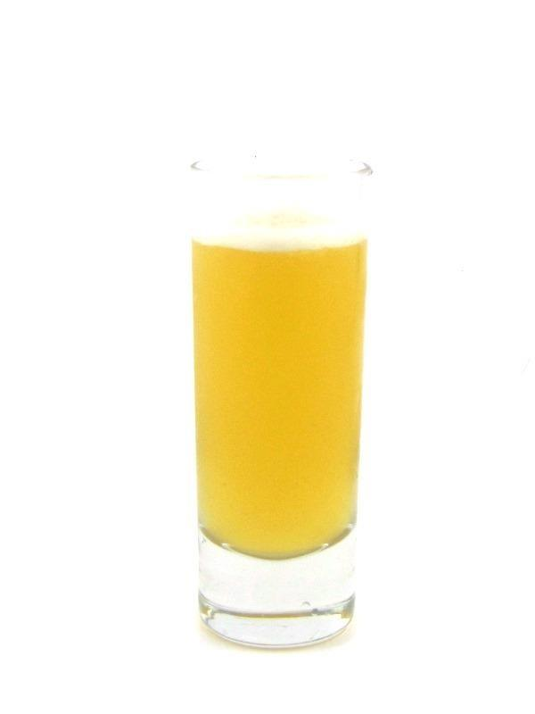

|  |  |
| --- | --- |
| **QUANTITY** | **INGREDIENTS:** |
| 0.5 fl oz | Captain Morgan’s Spiced Rum |
| 0.5 fl oz | Butter Ripple |
| 0.5 fl oz | Pineapple Juice |

**RECIPE:**

1. In a Mixing Glass, measure 0.5 fl oz Captain Morgan’s Spiced Rum,

0.5 fl oz Butter Ripple and 0.5 fl oz Pineapple Juice.

2. Pack Mixing glass full of ice. Top with a stainless steel shaking tin.

3. Shake vigorously 12 times to chill the ingredients.

4. Strain into a 2 oz shot glass.

5. Serve.

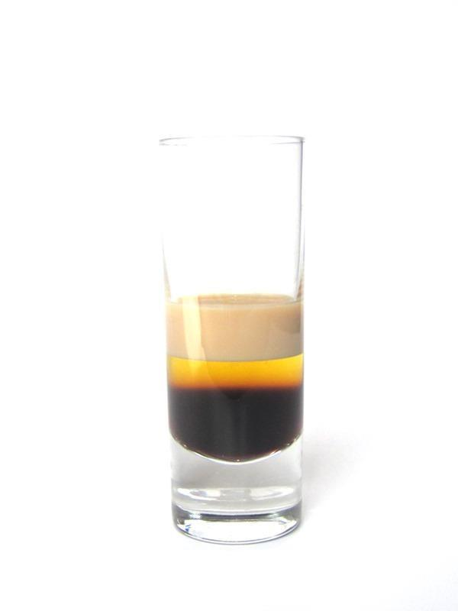

|  |  |
| --- | --- |
| **QUANTITY** | **INGREDIENTS:** |
| 0.33 fl oz | Kahlua |
| 0.33 fl oz | Banana Liqueur |
| 0.33 fl oz | Baileys |

**RECIPE:**

1. Measure 0.33 fl oz Kahlua into a 2 oz Shot Glass then layer 0.33 fl oz Banana Liqueur on top of Kahlua then layer 0.33 fl oz Baileys on top of Banana Liqueur.

2. Serve.

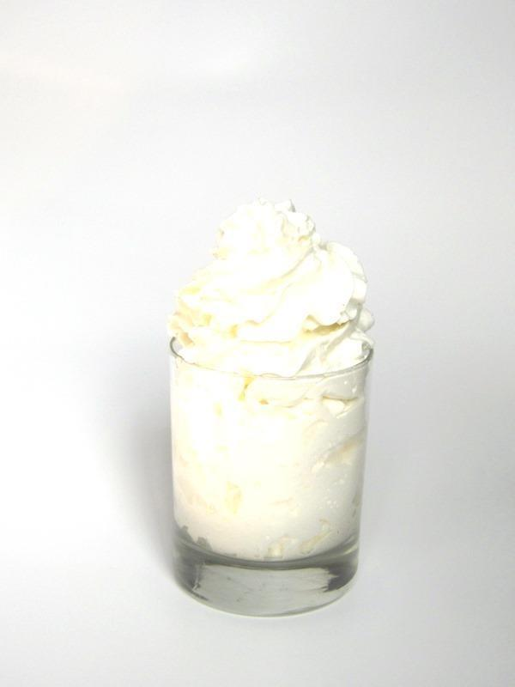

|  |  |
| --- | --- |
| **QUANTITY** | **INGREDIENTS:** |
| 1 fl oz | Baileys |
| 2 fl oz | Whip Cream |

**RECIPE:**

1. Measure 1 fl oz Baileys into a 2 oz shot glass. Place the shot in a single rocks glass.

2. Cover the entire drink with Whip Cream.

3. Serve.

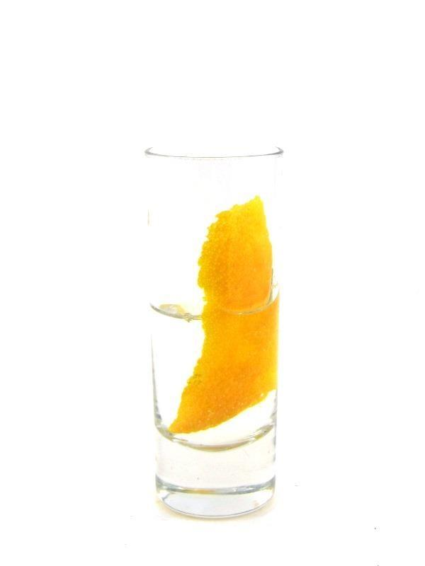

**GARNISH:** Wide Orange Zes t

|  |  |
| --- | --- |
| **QUANTITY** | **INGREDIENTS:** |
| 1 fl oz | Black Cherry Vodka |

**RECIPE:**

1. In a Mixing Glass, measure 1 fl oz Black Cherry Vodka.

2. Pack Mixing glass full of ice. Top with a stainless steel shaking tin.

3. Shake vigorously 12 times to chill the ingredients.

4. Strain into a 2 oz shot glass.

5. Garnish with a Wide Orange Zest.

6. Serve.

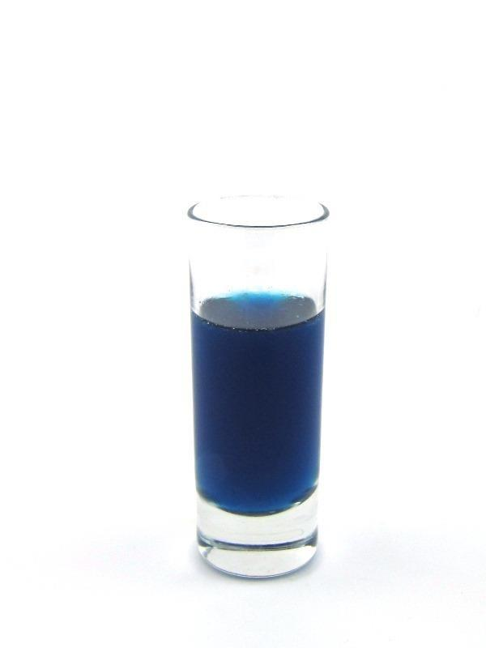

|  |  |
| --- | --- |
| **QUANTITY** | **INGREDIENTS:** |
| 0.5 fl oz | Blue Curacao |
| 0.5 fl oz | Sour Puss Raspberry |

**RECIPE:**

1. In a Mixing Glass, measure 0.5 fl oz Blue Curacao and 0.5 fl oz Sour

Puss Raspberry.

2. Pack Mixing glass full of ice. Top with a stainless steel shaking tin.

3. Shake vigorously 12 times to chill the ingredients.

4. Strain into a 2 oz shot glass.

5. Serve.

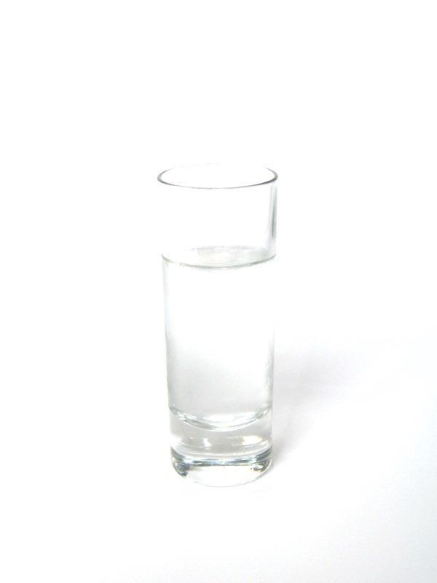

|  |  |
| --- | --- |
| **QUANTITY** | **INGREDIENTS:** |
| 0.5 fl oz | Crème de Cacao |
| 0.5 fl oz | Peppermint Schnapps |

**RECIPE:**

1. In a Mixing Glass, measure 0.5 fl oz Crème de Cacao and 0.5 fl oz

Peppermint Schnapps.

2. Pack Mixing glass full of ice. Top with a stainless steel shaking tin.

3. Shake vigorously 12 times to chill the ingredients.

4. Strain into a 2 oz shot glass.

5. Serve.

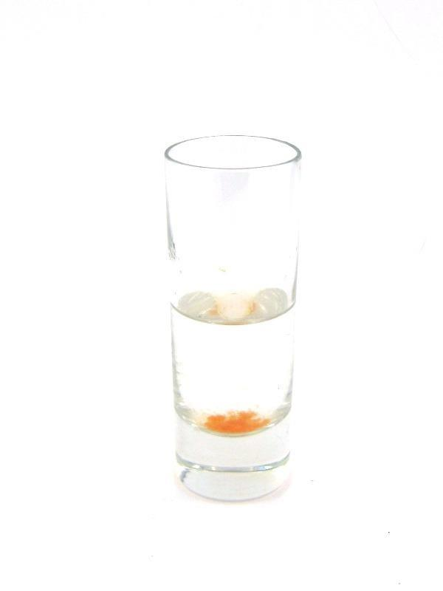

|  |  |
| --- | --- |
| **QUANTITY** | **INGREDIENTS:** |
| 1 fl oz | Well Tequila |
| 3 dashes | Red Tabasco |

**RECIPE:**

1. Measure 1 fl oz Well Tequila and 3 dashes Red Tabasco into a 2 oz Shot Glass.

2. Serve.

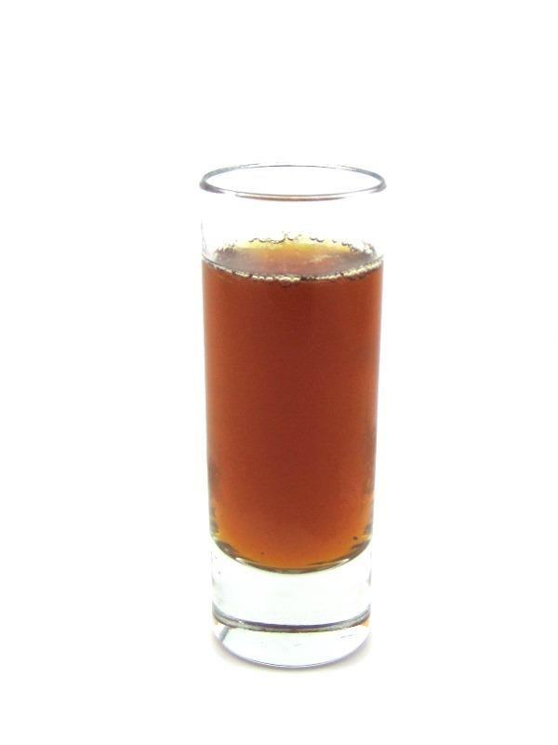

|  |  |
| --- | --- |
| **QUANTITY** | **INGREDIENTS:** |
| 0.5 fl oz | Jägermeister |
| 0.5 fl oz | Peach Liqueur |
| 0.5 fl oz | Cranberry Juice |

**RECIPE:**

1. In a Mixing Glass, measure 0.5 fl oz Jägermeister, 0.5 fl oz Peach

Liqueur and 0.5 fl oz Cranberry Juice.

2. Pack Mixing glass full of ice. Top with a stainless steel shaking tin.

3. Shake vigorously 12 times to chill the ingredients.

4. Strain into a 2 oz shot glass.

5. Serve.

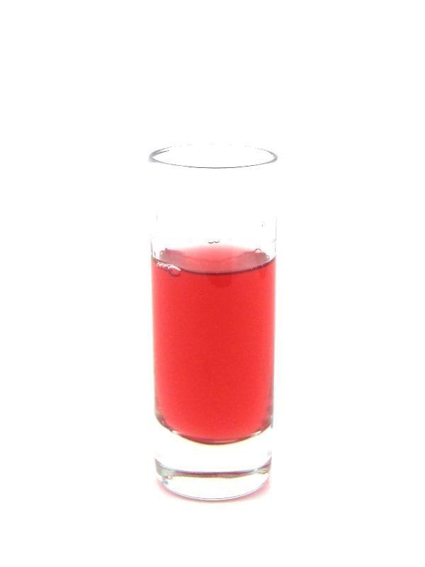

|  |  |
| --- | --- |
| **QUANTITY** | **INGREDIENTS:** |
| 0.5 fl oz | Bacardi 151 |
| 0.5 fl oz | Sour Puss Raspberry |

**RECIPE:**

1. In a Mixing Glass, measure 0.5 fl oz Bacardi 151 and 0.5 fl oz Sour

Puss Raspberry.

2. Pack Mixing glass full of ice. Top with a stainless steel shaking tin.

3. Shake vigorously 12 times to chill the ingredients.

4. Strain into a 2 oz shot glass.

5. Serve.

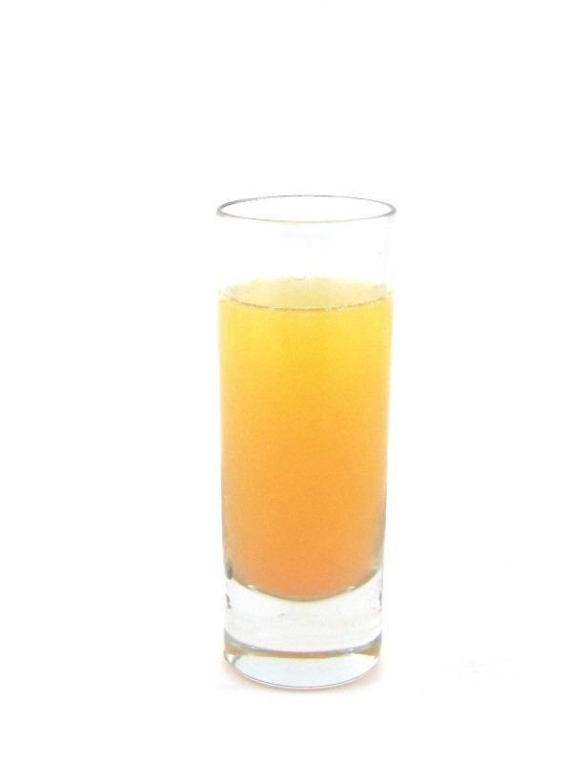

|  |  |
| --- | --- |
| **QUANTITY** | **INGREDIENTS:** |
| 0.5 fl oz | Well Vodka |
| 0.5 fl oz | Peach Liqueur |
| 0.25 fl oz | Cranberry Juice |
| 0.25 fl oz | Orange Juice |

**RECIPE:**

1. In a Mixing Glass, measure 0.5 fl oz Well Vodka, 0.5 fl oz Peach

Liqueur, 0.25 Cranberry Juice and 0.25 fl oz Orange Juice.

2. Pack Mixing glass full of ice. Top with a stainless steel shaking tin.

3. Shake vigorously 12 times to chill the ingredients.

4. Strain into a 2 oz shot glass.

5. Serve.

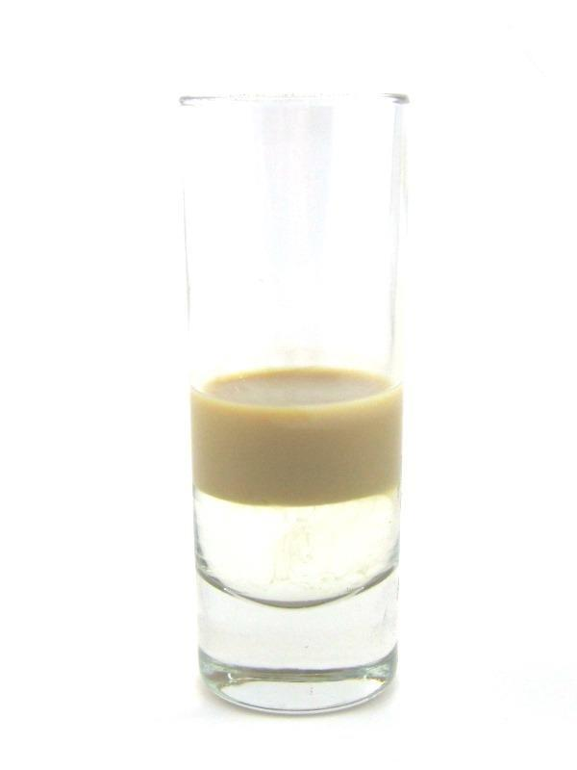

|  |  |
| --- | --- |
| **QUANTITY** | **INGREDIENTS:** |
| 0.5 fl oz | Sambuca White |
| 0.5 fl oz | Baileys |

**RECIPE:**

1. Measure 0.5 fl oz Sambuca White into a 2 oz Shot Glass then layer 0.5 fl oz Baileys on top of Sambuca White.

2. Serve.

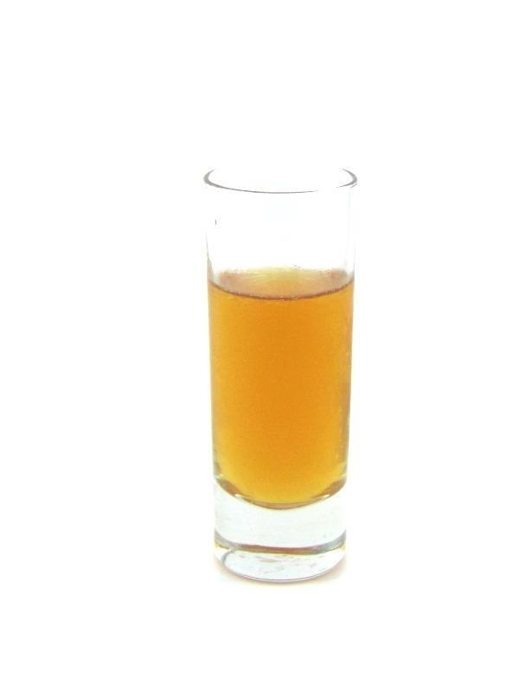

|  |  |
| --- | --- |
| **QUANTITY** | **INGREDIENTS:** |
| 0.5 fl oz | Amaretto |
| 0.5 fl oz | Southern Comfort |

**RECIPE:**

1. In a Mixing Glass, measure 0.5 fl oz Amaretto and 0.5 fl oz Southern

Comfort.

2. Pack Mixing glass full of ice. Top with a stainless steel shaking tin.

3. Shake vigorously 12 times to chill the ingredients.

4. Strain into a 2 oz shot glass.

5. Serve.

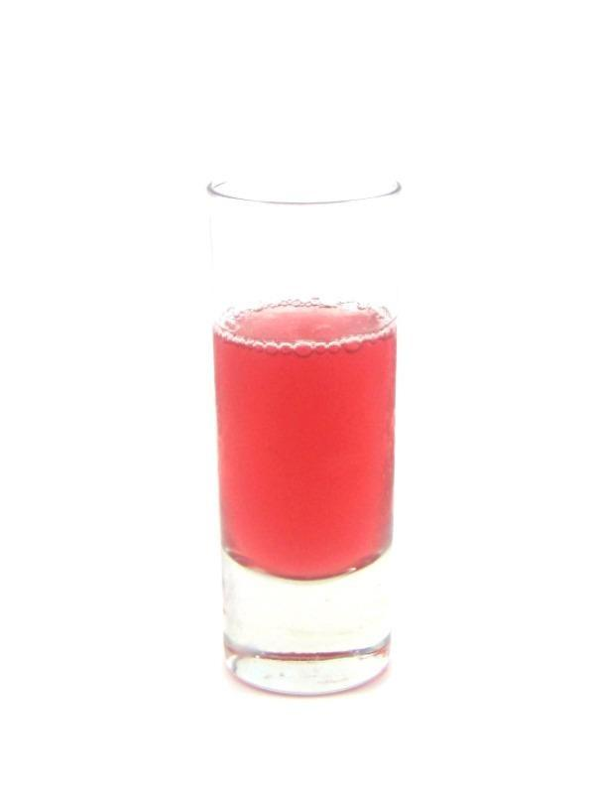

|  |  |
| --- | --- |
| **QUANTITY** | **INGREDIENTS:** |
| 0.5 fl oz | Jack Daniels |
| 0.5 fl oz | Sour Puss Raspberry |

**RECIPE:**

1. In a Mixing Glass, measure 0.5 fl oz Jack Daniels and 0.5 fl oz Sour

Puss Raspberry.

2. Pack Mixing glass full of ice. Top with a stainless steel shaking tin.

3. Shake vigorously 12 times to chill the ingredients.

4. Strain into a 2 oz shot glass.

5. Serve.

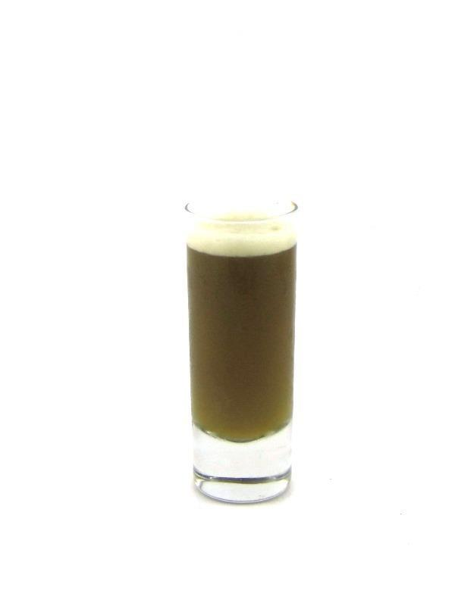

|  |  |
| --- | --- |
| **QUANTITY** | **INGREDIENTS:** |
| 0.5 fl oz | Malibu |
| 0.5 fl oz | Jägermeister |
| 0.5 fl oz | Pineapple Juice |

**RECIPE:**

1. In a Mixing Glass, measure 0.5 fl oz Malibu, 0.5 fl oz Jägermeister and 0.5 fl oz Pineapple Juice.

2. Pack Mixing glass full of ice. Top with a stainless steel shaking tin.

3. Shake vigorously 12 times to chill the ingredients.

4. Strain into a 2 oz shot glass.

5. Serve.

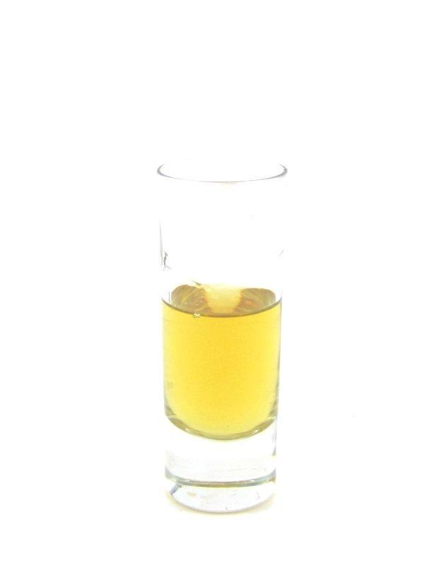

|  |  |
| --- | --- |
| **QUANTITY** | **INGREDIENTS:** |
| 0.33 fl oz | Well Tequila |
| 0.33 fl oz | Jack Daniels |
| 0.33 fl oz | Bacardi 151 |

**RECIPE:**

1. Measure 0.33 fl oz Well Tequila, 0.33 fl oz Jack Daniels and 0.33 fl oz Bacardi 151 into a 2 oz Shot Glass.

2. Serve.

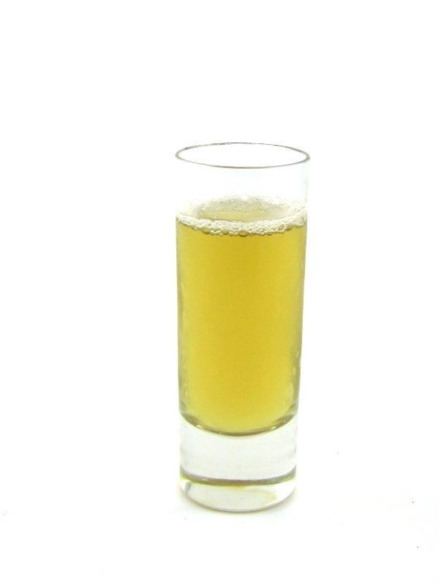

|  |  |
| --- | --- |
| **QUANTITY** | **INGREDIENTS:** |
| 0.5 fl oz | Crown Royal |
| 0.5 fl oz | Sour Puss Apple |
| 0.5 fl oz | Cranberry Juice |

**RECIPE:**

1. In a Mixing Glass, measure 0.5 fl oz Crown Royal, 0.5 fl oz Sour Puss

Apple and 0.5 fl oz Cranberry Juice.

2. Pack Mixing glass full of ice. Top with a stainless steel shaking tin.

3. Shake vigorously 12 times to chill the ingredients.

4. Strain into a 2 oz shot glass.

5. Serve.

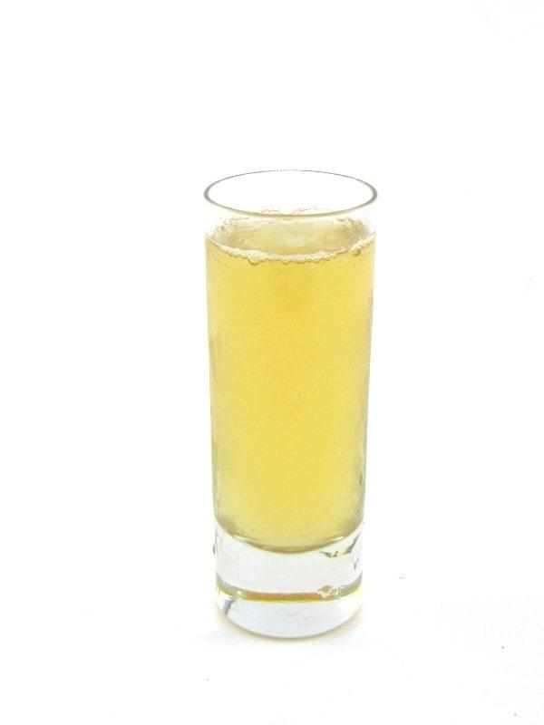

|  |  |
| --- | --- |
| **QUANTITY** | **INGREDIENTS:** |
| 0.5 fl oz | Peach Schnapps |
| 0.5 fl oz | Well Vodka |
| 0.5 fl oz | Cranberry Juice |

**RECIPE:**

1. In a Mixing Glass, measure 0.5 fl oz Peach Schnapps, 0.5 fl oz

Well Vodka and 0.5 fl oz Cranberry Juice

2. Pack Mixing glass full of ice. Top with a stainless steel shaking tin.

3. Shake vigorously 12 times to chill the ingredients.

4. Strain into a 2 oz shot glass.

5. Serve.

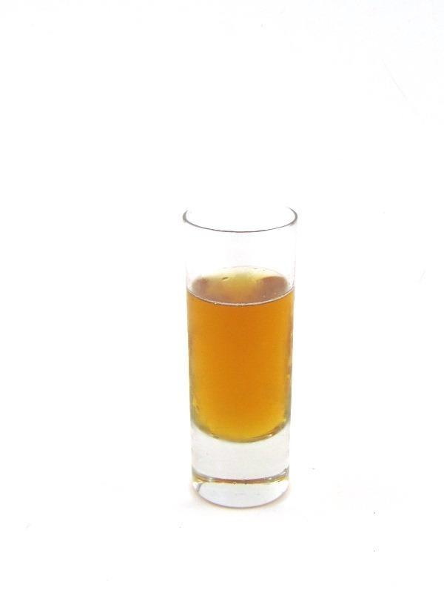

|  |  |
| --- | --- |
| **QUANTITY** | **INGREDIENTS:** |
| 0.25 fl oz | Well Tequila |
| 0.25 fl oz | Jägermeister |
| 0.25 fl oz | Peppermint Schnapps |
| 0.25 fl oz | Bacardi 151 |

**RECIPE:**

1. In a Mixing Glass, measure 0.25 fl oz Well Tequila, 0.25 fl oz

Jägermeister, 0.25 fl oz Peppermint Schnapps and 0.25 fl oz Bacardi

151.

2. Pack Mixing glass full of ice. Top with a stainless steel shaking tin.

3. Shake vigorously 12 times to chill the ingredients.

4. Strain into a 2 oz shot glass.

5. Serve.

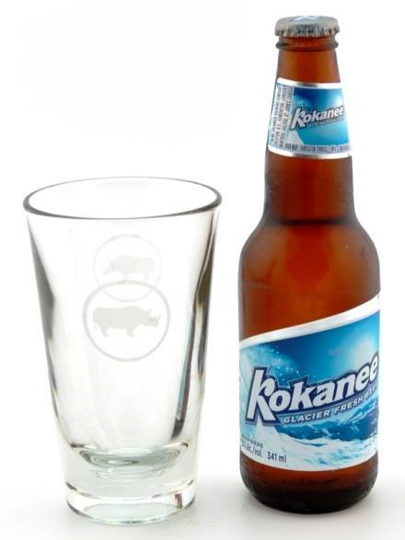

|  |  |
| --- | --- |
| **QUANTITY** | **INGREDIENTS:** |
| 1 each | Bottled Beer |

**RECIPE:**

1. Open bottle of Beer

2. Serve Beer with Chilled Sleeve

a. Place on Pick up for Server

b. Pour at 45° angle for guest at the bar

3. Place on a coaster.

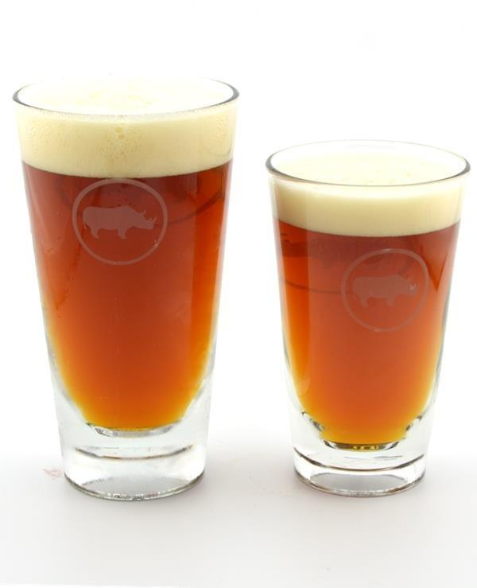

|  |  |
| --- | --- |
| **QUANTITY** | **INGREDIENTS:** |
| 12 or 18 fl oz | Draught Beer |

**RECIPE:**

1. Remove glass from glass chiller

2. Rinse glass to remove ice with beer glass spray. This helps prevent foaming and retains the foam head on a beer.

3. Hold glass directly under chosen tap at a 45° angle

4. Open tap FULLY to dispense beer until foam head reaches the top of the glass. Creating a 1” inch foam head.

5. Close tap in one quick motion and move glass away from tap to prevent any drops falling in the beer.

6. Serve ALL draught beer to guest on a Coaster.

**STELLA:**

1. Follow the above steps for Stella Artois then:

2. Let beer overflow glass by less than 1 fl oz.

3. Using Stella knife cut the large bubbles from the head of the beer. This helps retain the foam head throughout the life of the beer.

**GLASSWARE:**

1. Use branded glassware for any necessary beers.

2. Pint Glasses and Sleeves are used for EVERY other beer.

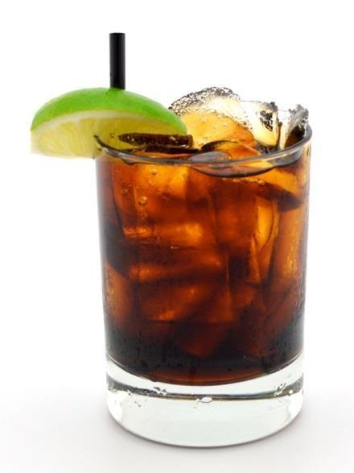

|  |  |
| --- | --- |
| **QUANTITY** | **INGREDIENTS:** |
| 1 fl oz | Spirit of Choice |
| 4 fl oz | Soda or Juice |

**RECIPE:**

1. Pack a Double Rocks glass full of ice.

2. Measure 1 fl oz Spirit of Choice and fill with aprox. 4 fl oz Soda or Juice of choice over ice.

3. Offer guest a choice of Lime Wedge, Lemon Wedge or No Fruit.

4. Garnish with guests selection.

5. Add a 6” Straw.

**DOUBLE:** Add 1 fl oz spirit of choice.

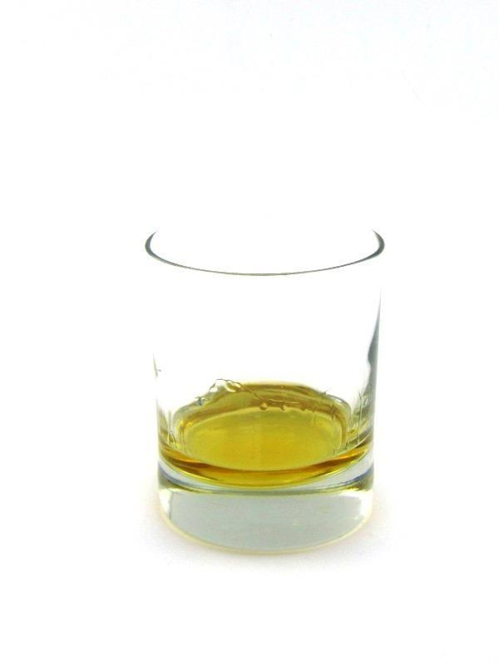

|  |  |
| --- | --- |
| **QUANTITY** | **INGREDIENTS:** |
| 1 fl oz | Spirit of Choice |

**RECIPE:**

1. Measure 1 fl oz Spirit of Choice

**DOUBLE:** Add 1 fl oz spirit of choice.

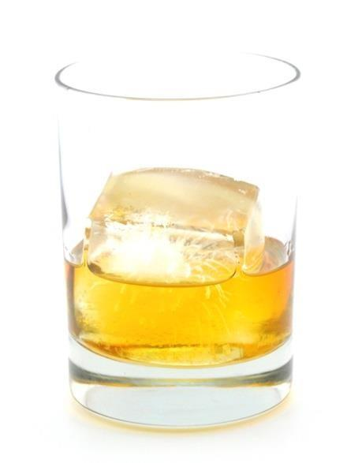

|  |  |
| --- | --- |
| **QUANTITY** | **INGREDIENTS:** |
| 1 fl oz | Spirit of Choice |

**RECIPE:**

1. Add one Big Ass Ice Cube to Single Rocks Glass

2. Measure 1 fl oz Spirit of Choice

**DOUBLE:** Add 1 fl oz spirit of choice.

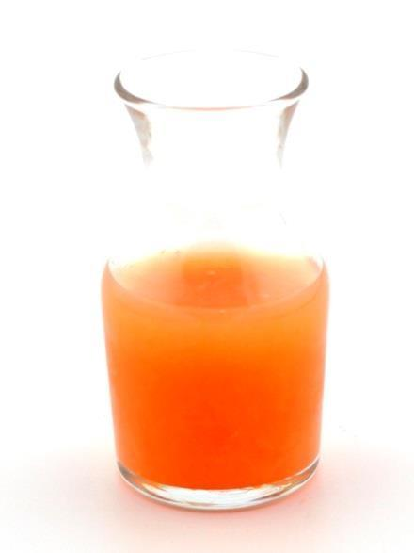

|  |  |
| --- | --- |
| **QUANTITY** | **INGREDIENTS:** |
| 3 fl oz | Mix of Choice |

**RECIPE:**

1. Measure 3 fl oz Mix of Choice

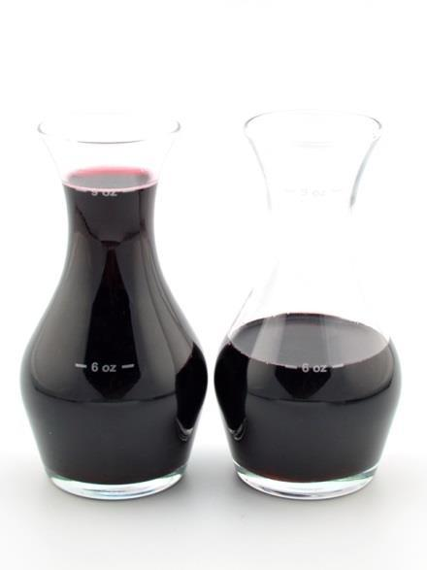

|  |  |
| --- | --- |
| **QUANTITY** | **INGREDIENTS:** |
| 6 or 9 fl oz | Wine |

**RECIPE:**

1. Measure 6 or 9 fl oz Wine of choice in Wine Carafe to correct line.

2. Present with spotlessly clean and polished wine glass.

3. Pour aprox. 2 fl oz taste into wine glass for guest.

4. Place remaining wine in carafe to the right of the glass upon guest approval.

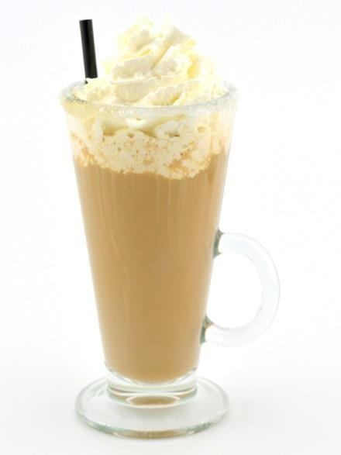

|  |  |
| --- | --- |
| **QUANTITY** | **INGREDIENTS:** |
| 0.5 fl oz | Baileys |
| 0.25 fl oz | Grand Marnier |
| 0.25 fl oz | Kahlua |
| 5 fl oz | Fresh Coffee |

**RECIPE:**

1. Rim a specialty Coffee Mug with Sugar.

2. Measure 0.5 fl oz Baileys, 0.25 fl oz Grand Marnier, 0.25 fl oz Kahlua and 5 fl oz Coffee into a Sugar rimmed Specialty Coffee mug.

3. Top with Whipped Cream

4. Add 8” Straw

**DOUBLE:** Add 0.5 fl oz Baileys, 0.25 fl oz Grand Marnier & 0.25 fl oz Kahlua



|  |  |
| --- | --- |
| **QUANTITY** | **INGREDIENTS:** |
| 1 fl oz | Baileys |
| 5 fl oz | Fresh Hot Coffee |

**RECIPE:**

1. Rim a specialty Coffee Mug with Sugar.

2. Measure 1 fl oz Baileys and 5 fl oz Coffee into a Sugar rimmed

Specialty Coffee mug.

3. Top with Whipped Cream

4. Add 8” Straw.

**DOUBLE:** Add 1 fl oz Baileys

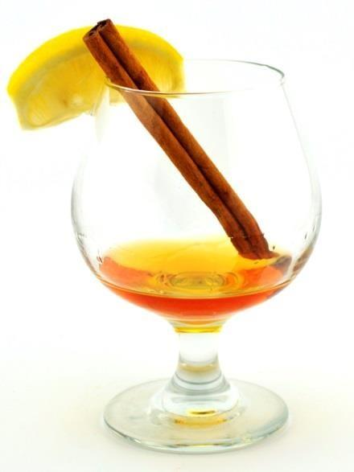

|  |  |
| --- | --- |
| **QUANTITY** | **INGREDIENTS:** |
| 0.5 fl oz | Amaretto |
| 0.5 fl oz | Grand Marnier |
| Pot | English Breakfast Tea |

**RECIPE:**

1. Heat a Snifter with Hot Water from Tea Water Dispenser

2. Discard Water.

3. In a Snifter: measure 0.5 fl oz Amaretto and 0.5 fl oz Grand Marnier

4. Garnish with a Cinnamon Stick and a Lemon Wedge.

5. Serve with a pot of English Breakfast Tea. Server should begin the steeping of the tea prior to presentation at the table.

**DOUBLE:** Add 0.5 fl oz Amaretto & 0.5 fl oz Grand Marnier

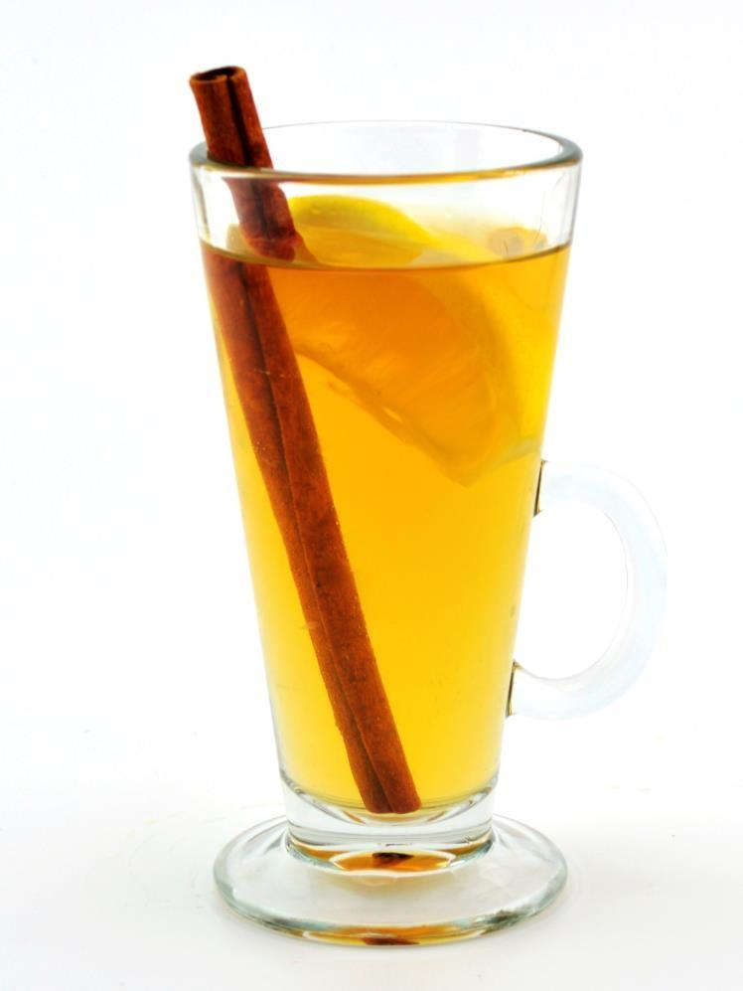

|  |  |
| --- | --- |
| **QUANTITY** | **INGREDIENTS:** |
| 0.5 fl oz | Well Dark Rum |
| 0.5 fl oz | St. Remy Brandy |
| Teaspoon | Sugar |
| Wedge | Lemon |
| 4 fl oz | Boiling Water |

**RECIPE:**

1. In a Specialty Coffee Mug; measure 0.5 fl oz Well Dark Rum, 0.5 fl oz Brandy, teaspoon of Sugar, squeeze a lemon wedge and 4 fl oz Boiling Water.

2. Add Cinnamon Stick and Stir

**DOUBLE:** Add 0.5 fl oz Well Dark Rum & 0.5 fl oz Brandy

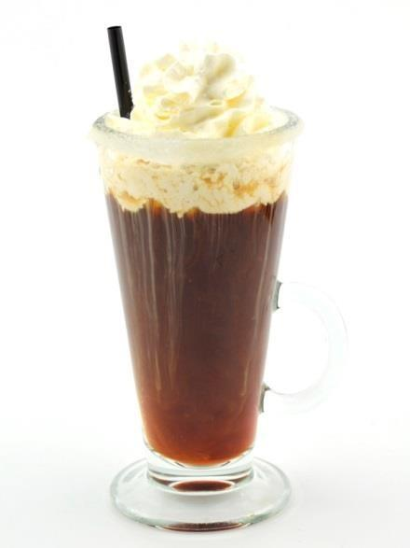

|  |  |
| --- | --- |
| **QUANTITY** | **INGREDIENTS:** |
| 1 fl oz | Irish Whiskey |
| 5 fl oz | Fresh Hot Coffee |

**RECIPE:**

1. Rim a specialty Coffee Mug with Sugar.

2. Measure 1 fl oz Irish Whisky and 5 fl oz Coffee into a Sugar rimmed

Specialty Coffee mug.

3. Top with Whipped Cream

4. Add 8” Straw

**DOUBLE:** Add 1 fl oz Irish Whiskey



|  |  |
| --- | --- |
| **QUANTITY** | **INGREDIENTS:** |
| 0.5 fl oz | Kahlua |
| 0.5 fl oz | El Jimador Reposado |
| 5 fl oz | Fresh Hot Coffee |

**RECIPE:**

1. Rim a specialty Coffee Mug with Sugar.

2. Measure 0.5 fl oz El Jimador Reposado, 0.5 fl oz Kahlua and 5 fl oz

Coffee into a Sugar rimmed Specialty Coffee mug.

3. Top with Whipped Cream

4. Add 8” Straw

**DOUBLE:** Add 0.5 fl oz Kahlua & 0.5 fl oz El Jimador Reposado.



|  |  |
| --- | --- |
| **QUANTITY** | **INGREDIENTS:** |
| 0.5 fl oz | Grand Marnier |
| 0.5 fl oz | Kahlua |
| 5 fl oz | Fresh Hot Coffee |

**RECIPE:**

1. Rim a specialty Coffee Mug with Sugar.

2. Measure 0.5 fl oz Grand Marnier, 0.5 fl oz Kahlua and 5 fl oz Coffee into a Sugar rimmed Specialty Coffee mug.

3. Top with Whipped Cream

4. Add 8” Straw

**DOUBLE:** Add 0.5 fl oz Grand Marnier& 0.5 fl oz Kahlua



|  |  |
| --- | --- |
| **QUANTITY** | **INGREDIENTS:** |
| 0.5 fl oz | Grand Marnier |
| 0.5 fl oz | Kahlua |
| 5 fl oz | Fresh Hot Coffee |

**RECIPE:**

1. Rim a specialty Coffee Mug with Sugar.

2. Measure 0.5 fl oz Grand Marnier, 0.5 fl oz Kahlua and 5 fl oz Coffee into a Sugar rimmed Specialty Coffee mug.

3. Top with Whipped Cream

4. Add 8” Straw

**DOUBLE:** Add 0.5 fl oz Grand Marnier& 0.5 fl oz Kahlua

**ALTERNATIVE (MADRID):**

1. Build drink in wine glass with no sugar rim.

2. Drizzle 0.25 oz of Triple Sec over top of whipped cream.



|  |  |
| --- | --- |
| **QUANTITY** | **INGREDIENTS:** |
| 0.5 fl oz | Kahlua |
| 0.5 fl oz | St. Remy Brandy |
| 5 fl oz | Fresh Hot Coffee |

**RECIPE:**

1. Rim a specialty Coffee Mug with Sugar.

2. Measure 0.5 fl oz Brandy, 0.5 fl oz Kahlua and 5 fl oz Coffee into a

Sugar rimmed Specialty Coffee mug.

3. Top with Whipped Cream

4. Add 8” Straw

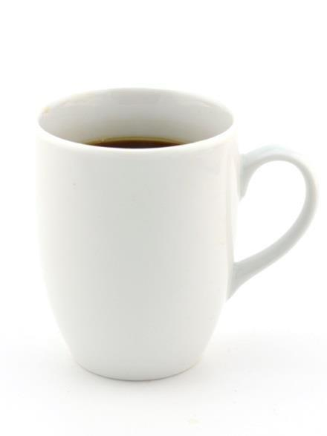

|  |  |
| --- | --- |
| **QUANTITY** | **INGREDIENTS:** |
| 10 fl oz | Hot Coffee |

**RECIPE:**

1. Fill Coffee Cup with approx. 10 fl oz Hot Coffee.

2. Serve with a Tea Spoon and Cream and Sugar for the table.

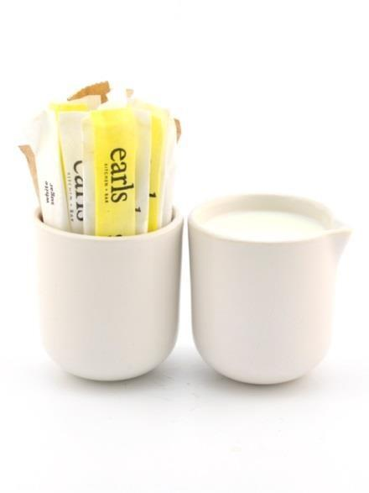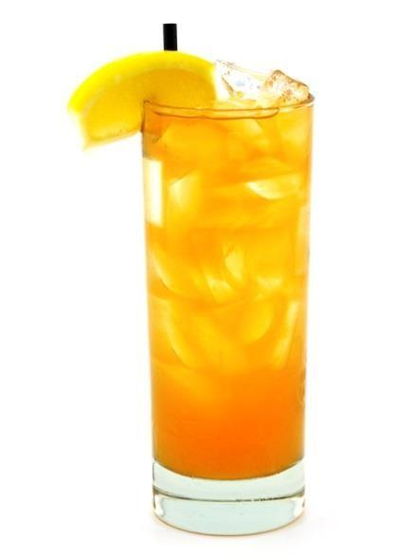

|  |  |
| --- | --- |
| **QUANTITY** | **INGREDIENTS:** |
| 0.75 fl oz | House Made Simple Syrup |
| 0.75 fl oz | Fresh Lemon Juice |
| 2 fl oz | Water |
| 3 fl oz * | Iced Tea *(fill with) |

**RECIPE:**

1. Pack a Collins glass full of ice.

2. Measure 0.75 fl oz Simple Syrup, 0.75 fl oz Lemon Juice, 2 fl oz Water, and fill with 3 fl oz Iced Tea.

3. Insert bar spoon and **STIR** to thoroughly mix ingredients.

4. Top with ice level with the rim of the glass.

5. Garnish with a Lemon Wedge

6. Add a 8” straw

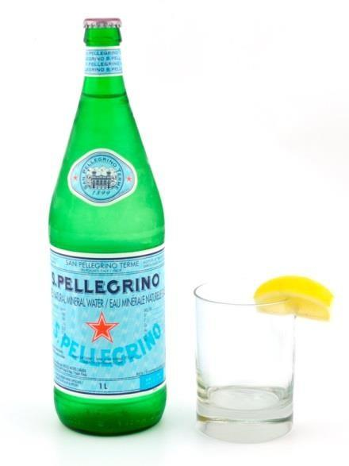

|  |  |
| --- | --- |
| **QUANTITY** | **INGREDIENTS:** |
| 1 btl | Bottled Water |

**RECIPE:**

1. Open bottle of water.

2. Garnish appropriate number of Double Rocks glasses with lemon wedges.

3. Serve with Wine Chiller

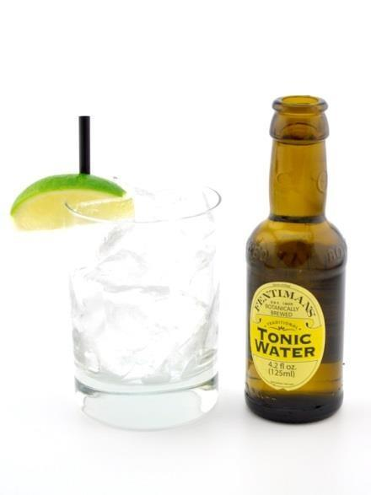

|  |  |
| --- | --- |
| **QUANTITY** | **INGREDIENTS:** |
| 1 btl | Fentiman’s Tonic Water |

**RECIPE:**

1. Open bottle of Fentiman’s Tonic Water.

2. Pack Double Rocks Glass full of ice.

3. Garnish with a Lime Wedge.

4. Add a 6” Straw.

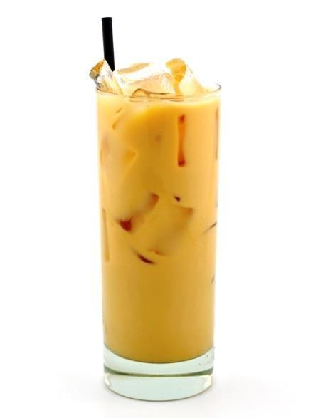

|  |  |
| --- | --- |
| **QUANTITY** | **INGREDIENTS:** |
| 2 fl oz | Cold Espresso |
| 1 fl oz | Simple Syrup |
| 3 fl oz | Homogenized Milk |

**RECIPE:**

1. Pack a Collins glass full of ice and measure 2 fl oz Cold Espresso, 1 fl oz Simple Syrup and 3 fl oz Homogenized Milk.

2. Stir thoroughly to mix ingredients.

3. Add a 8” straw

**NOTE:** Iced espresso prepared in advance and refrigerated.

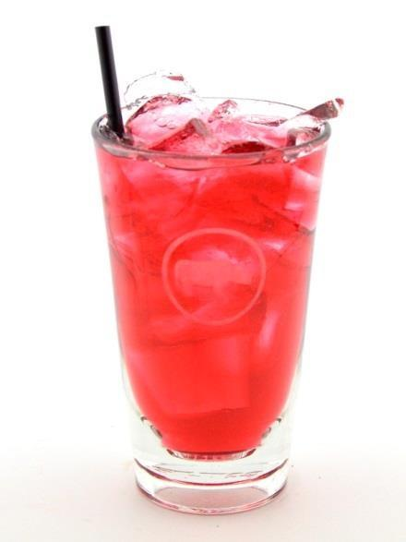

|  |  |
| --- | --- |
| **QUANTITY** | **INGREDIENTS:** |
| 5 or 7 fl oz | Juice (Apple, Cranberry, Clamato, Pineapple) |

**RECIPE:**

1. Pack appropriate Glass full of ice.

a. Small = Double Rocks Glass b. Large = Sleeve

2. Fill with Juice.

3. Add an appropriate sized Straw. a. Small = 6”

b. Large = 8”

**NOTE: Juices listed above are poured over ice by our standard. We will pour any juice over ice by guest request.**

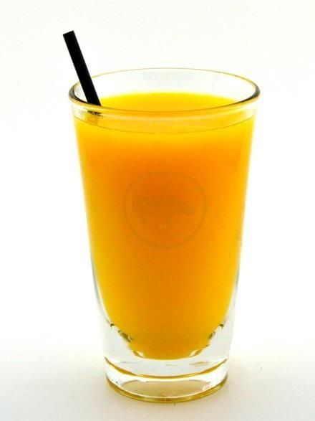

|  |  |
| --- | --- |
| **QUANTITY** | **INGREDIENTS:** |
| 10 or 12 fl oz | Juice (Fresh OJ, Grapefruit, Tomato, or Milk) |

**RECIPE:**

1. Fill appropriate Glass with Juice.

a. Small = Double Rocks Glass b. Large = Sleeve

2. Add an appropriate sized Straw. a. Small = 6”

b. Large = 8”

**NOTE: Juices listed above are poured without ice by our standard. We will pour any juice without ice by guest request.**



|  |  |
| --- | --- |
| **QUANTITY** | **INGREDIENTS:** |
| 4 fl oz | Juice (Apple, Cranberry, Clamato, Pineapple) |
| 3 fl oz | Soda Water |

**RECIPE:**

1. Pack Sleeve full of ice.

2. Fill with ½ full with approx. 4 fl oz Juice.

3. Top with approx. 3 fl oz Soda Water.

4. Add a 8” Straw.

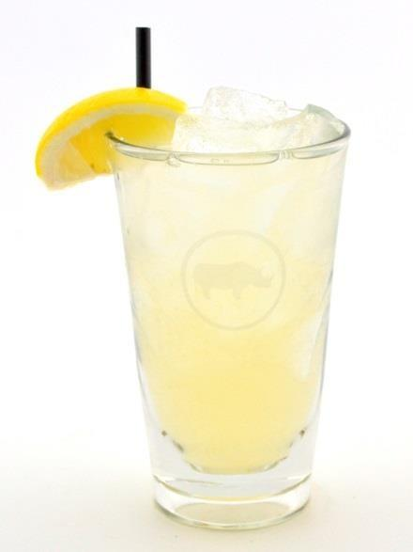

|  |  |
| --- | --- |
| **QUANTITY** | **INGREDIENTS:** |
| 1 fl oz | Simple Syrup |
| 1 fl oz | Fresh Lemon Juice |
| 5 fl oz | Water |

**RECIPE:**

1. Pack Sleeve full of ice.

2. Measure 1 fl oz Simple Syrup and 1 fl oz Fresh Lemon Juice.

3. Top with approx. 5 fl oz Water.

4. Insert bar spoon and stir to thoroughly mix ingredients.

5. Garnish with a Lemon Wedge

6. Add an 8” Straw.

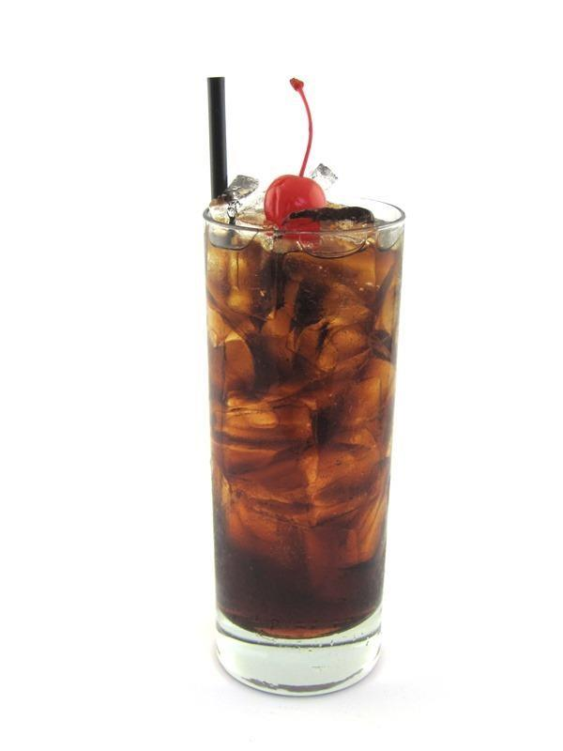

|  |  |
| --- | --- |
| **QUANTITY** | **INGREDIENTS:** |
| 7 fl oz | Coke |
| 1 fl oz | Grenadine |

**RECIPE:**

1. Pack a Collins glass full of ice.

2. Add 1 fl oz Grenadine

3. Top with Coke

4. Garnish with a Candied Cherry

5. Add an 8” straw

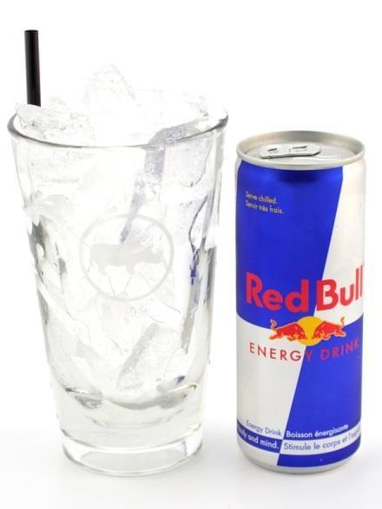

|  |  |
| --- | --- |
| **QUANTITY** | **INGREDIENTS:** |
| 1 can | Red Bull or Sugar Free Red Bull |

**RECIPE:**

1. Open can of Red Bull

2. Pack a Sleeve full of ice.

3. Add an 8” Straw.

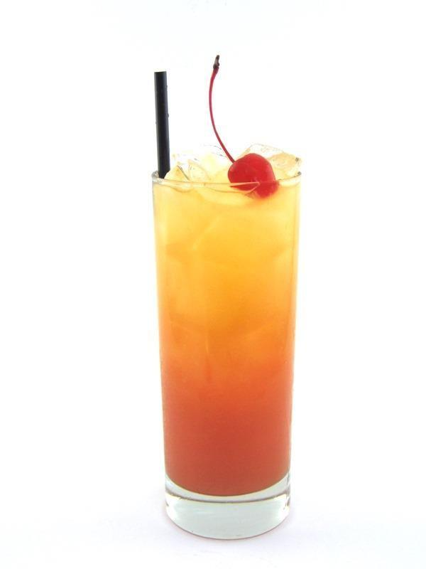

|  |  |
| --- | --- |
| **QUANTITY** | **INGREDIENTS:** |
| 3 fl oz | Orange Juice |
| 3 fl oz | Sprite |
| 1 fl oz | Grenadine |

**RECIPE:**

1. Pack a Collins glass full of ice.

2. Add 1 fl oz Grenadine

3. Top with 3 fl oz Orange Juice and 3 fl oz Sprite

4. Garnish with a Candied Cherry

5. Add an 8” straw

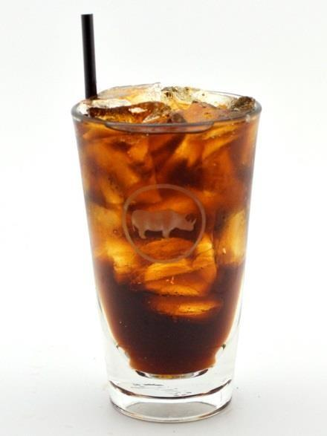

|  |  |
| --- | --- |
| **QUANTITY** | **INGREDIENTS:** |
| 5 or 7 fl oz |  |

**RECIPE:**

1. Pack appropriate Glass full of ice.

a. Small = Double Rocks Glass b. Large = Sleeve

2. Fill with Pop.

3. Add an appropriate sized Straw. a. Small = 6”

b. Large = 8”

**NOTE: Juices listed above are poured over ice by our standard. We will pour any juice over ice by guest request.**

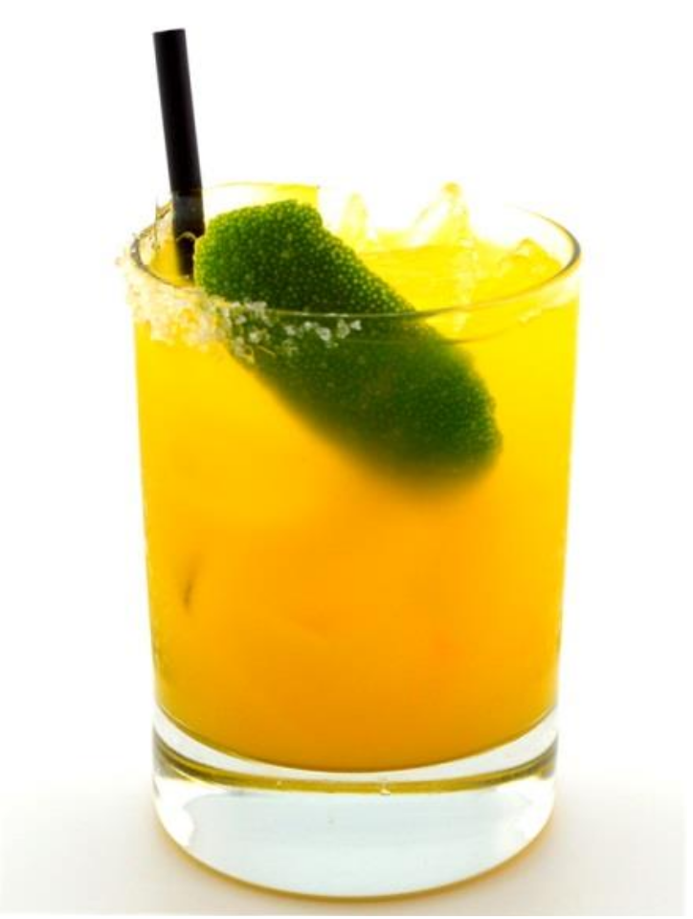

|  |  |
| --- | --- |
| **QUANTITY** | **INGREDIENTS:** |
| 1 fl oz | Fruit Puree (strawberry, mango, raspberry, etc.) |
| 1 fl oz | Simple Syrup |
| 1 fl oz | Lime Juice |
| 1 fl oz | Water |

**RECIPE:**

1. Rim Double Rocks glass with a ½ rim of Margarita Salt and fill with ice.

2. In a Mixing Glass measure 1 fl oz Fruit Puree, 1 fl oz Simple Syrup, 1 fl oz Fresh Lime Juice and 1 fl oz Water.

3. Pack Mixing glass with ice and top with stainless steel Shaking tin.

4. Shake vigorously 12 times to mix ingredients.

5. Strain over fresh ice into the ½ salt rimmed Double Rocks glass.

6. Garnish with a Lime Zest.

7. Add a 6” Straw.

**NOTE: For lime flavored replace puree with additional 1 fl oz water.**